Creating a user and Custom password in ec2 windows server

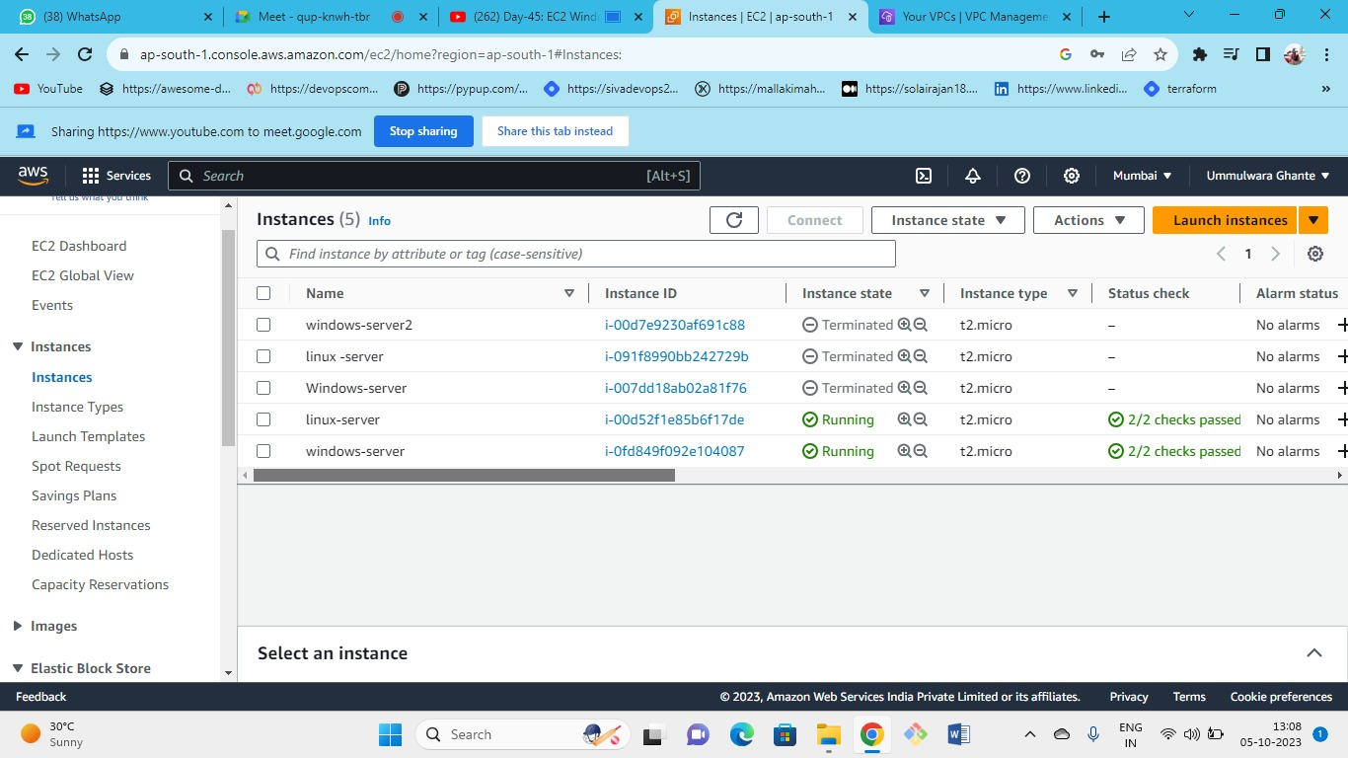



Launch normal Windows server instance

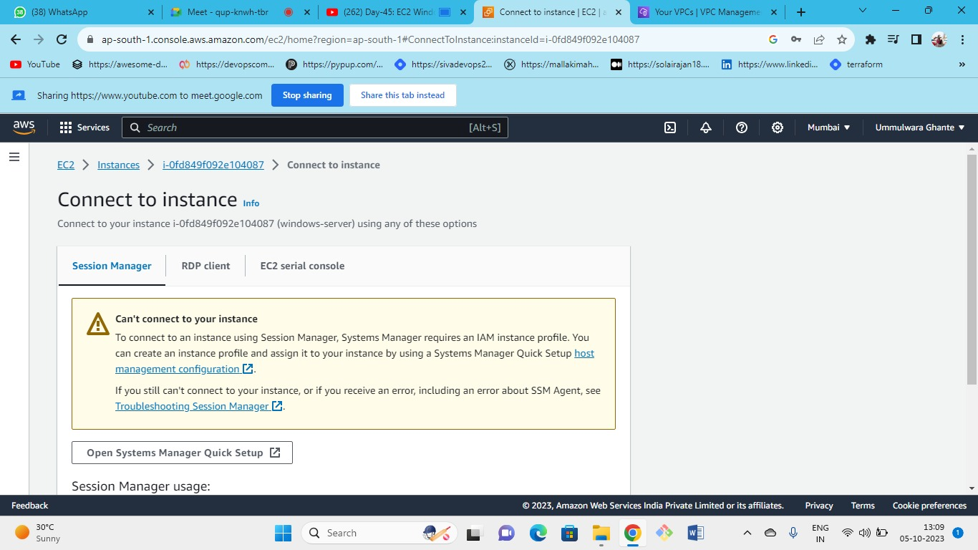



Connect the instance using RDP Client decrypt the password using the downloaded keypair

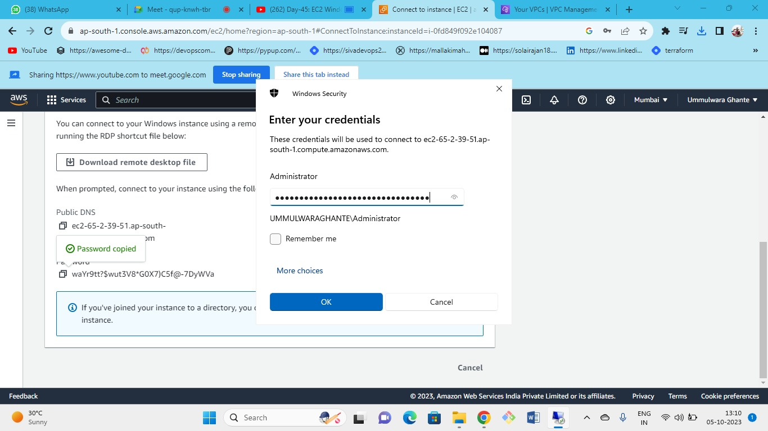



In remote desktop connection paste the public DNS 🡪 for connect put username and decrypted password

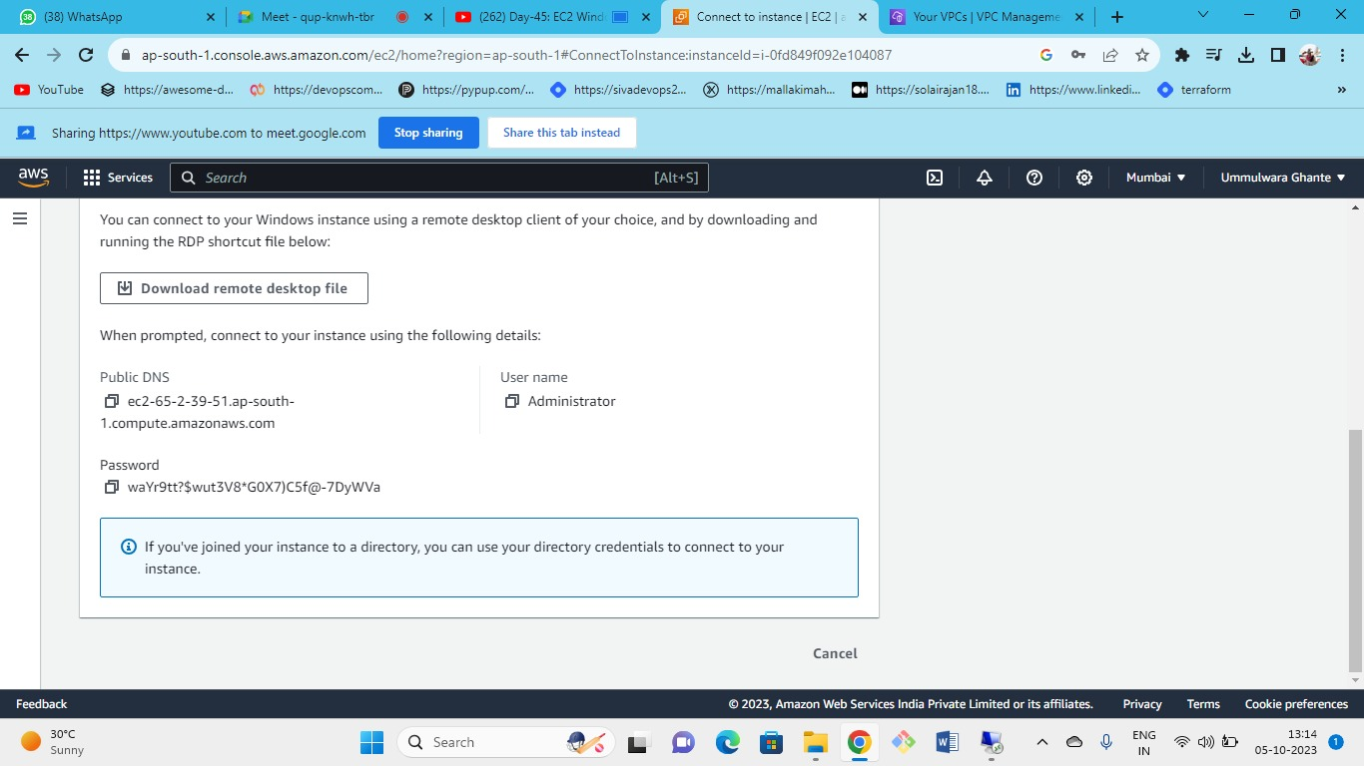



As you can see with the same key pair of Windows server when you retrieve the password it is the same (i.e. for a single instance when you use the same keypair password doesn’t change the password is different when you use same keypair for multiple windows server)

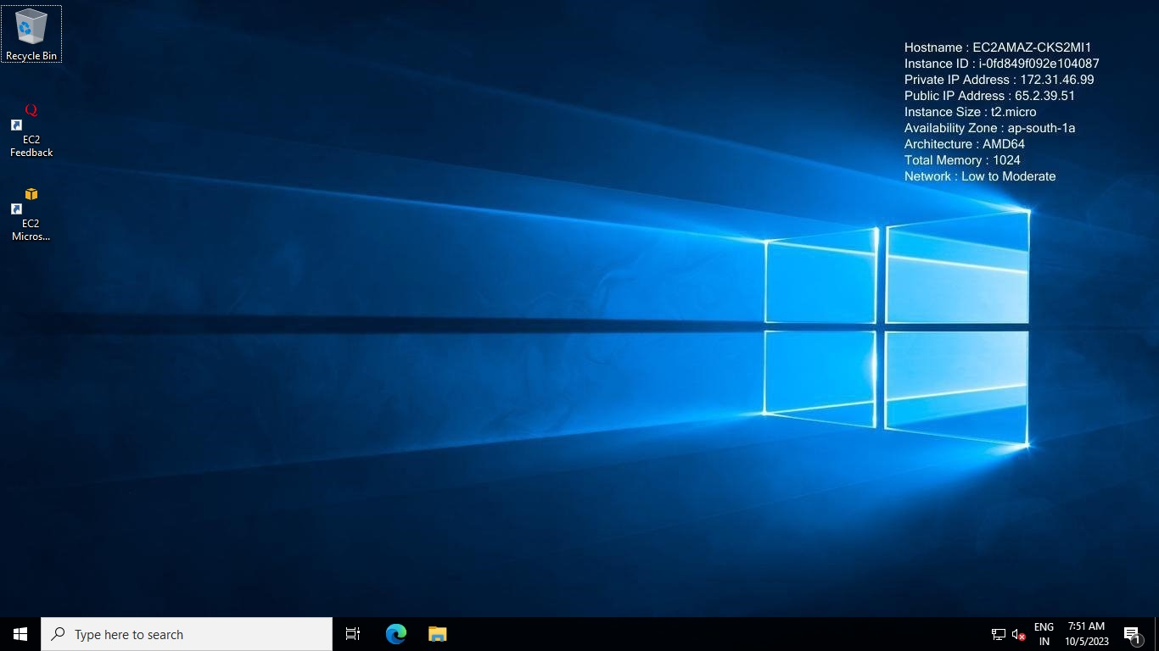

Here we have connected our Windows server successfully

* every instance has one public and private ID
* every resource we create is under VPC
* without VPC and subnet you cannot launch ec2 instances
* memory is nothing but the ram

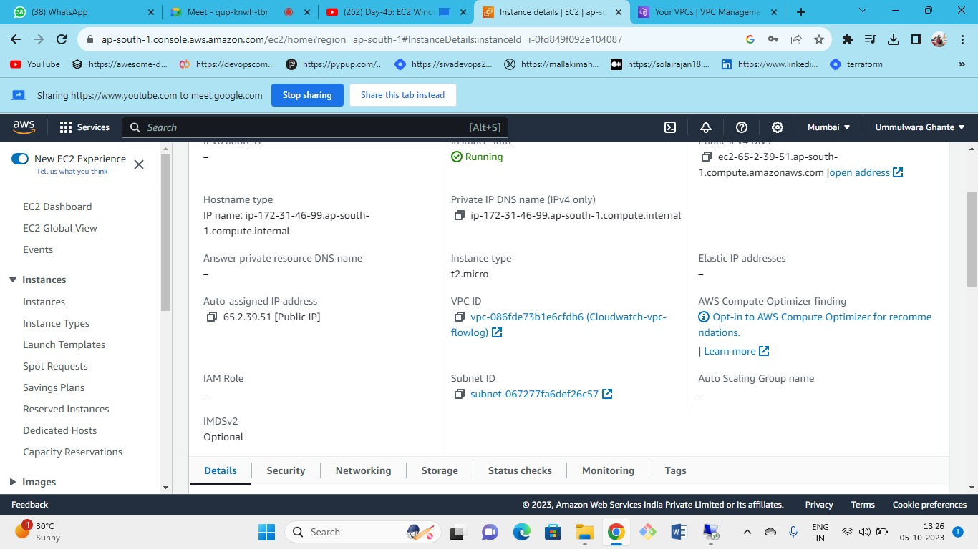



Here we can see our VPC and Subnet ID that we have selected to launch our instance

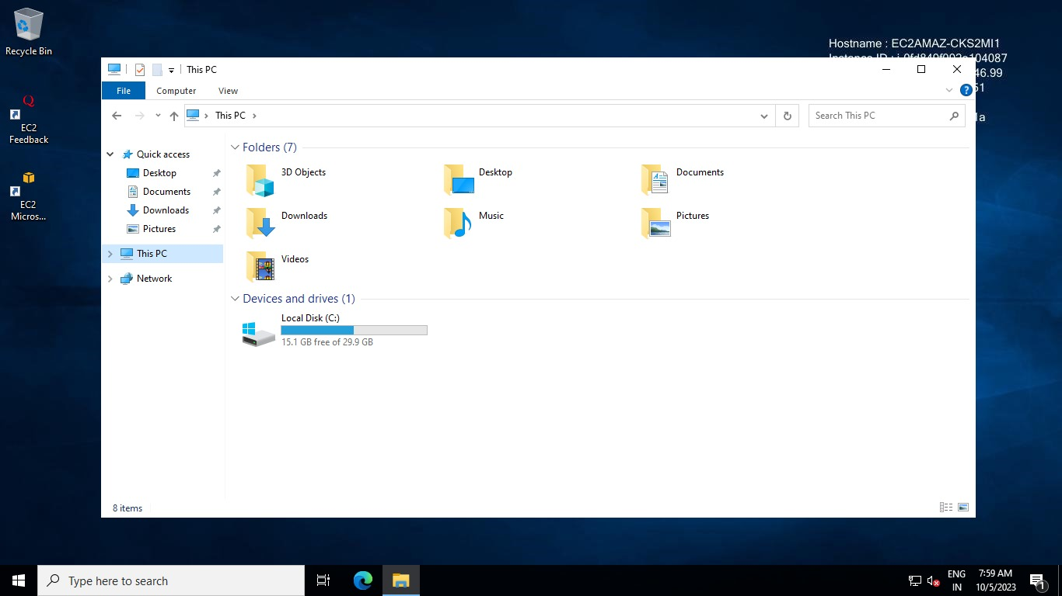

Inside our launched instance in (this PC🡪 check for local disk storage we have 30GB)

storage details of the disk are visible here

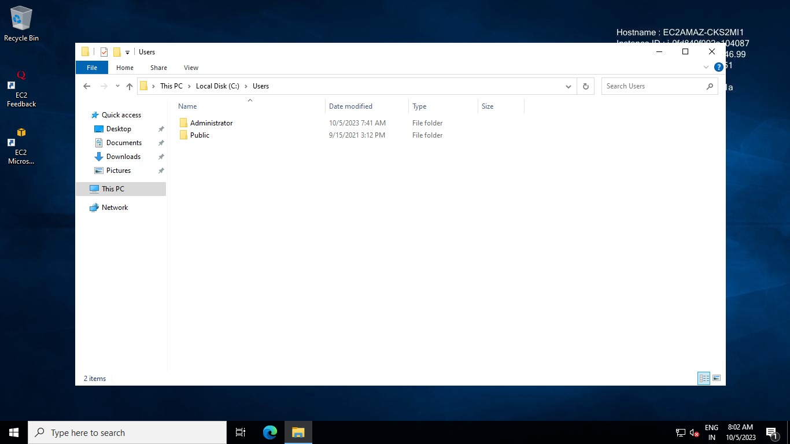

Inside storage -->user--> as a user administrator is present

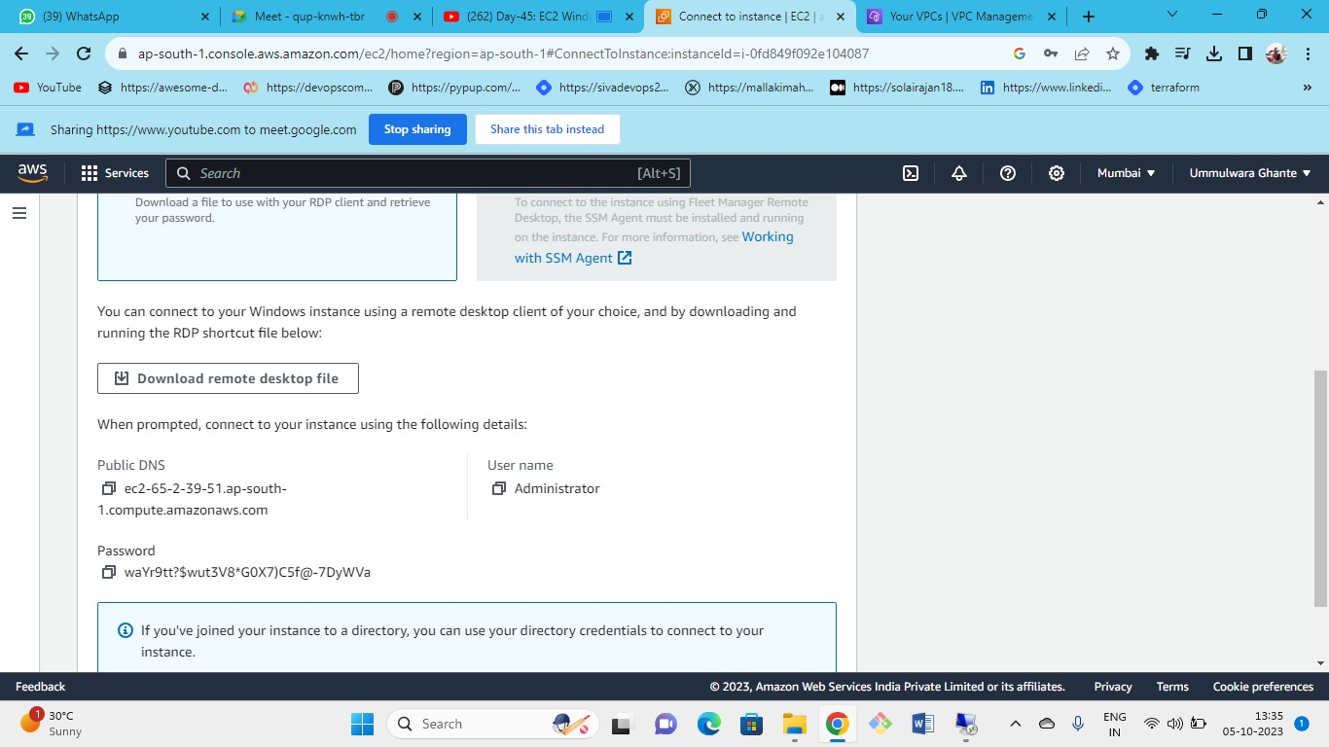



we have retrieved the password but now we need to set our own custom password so that we do not want to use the key pair again and again.

So to set custom password

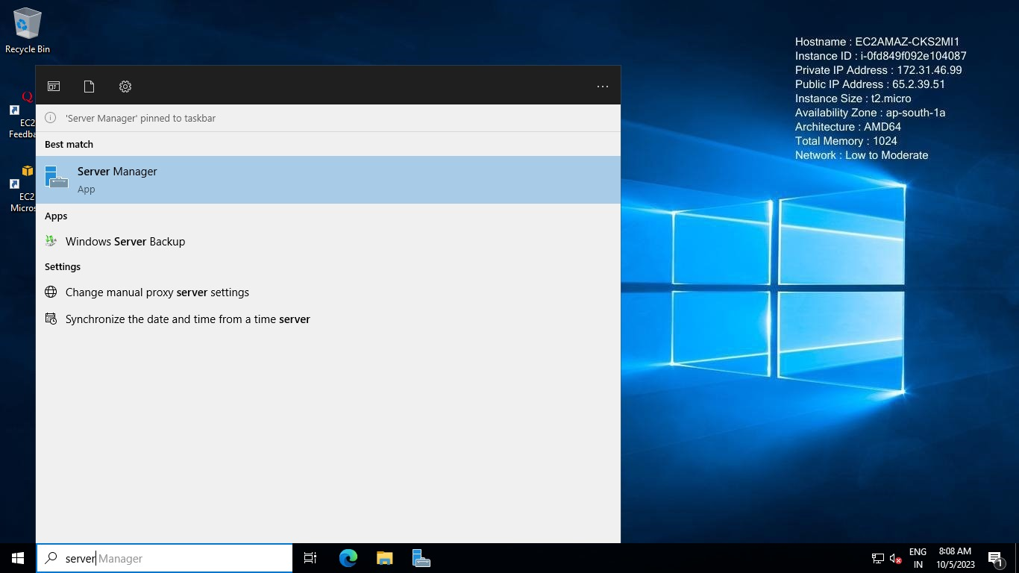

Go inside our launched instance and search for **Server Manager**

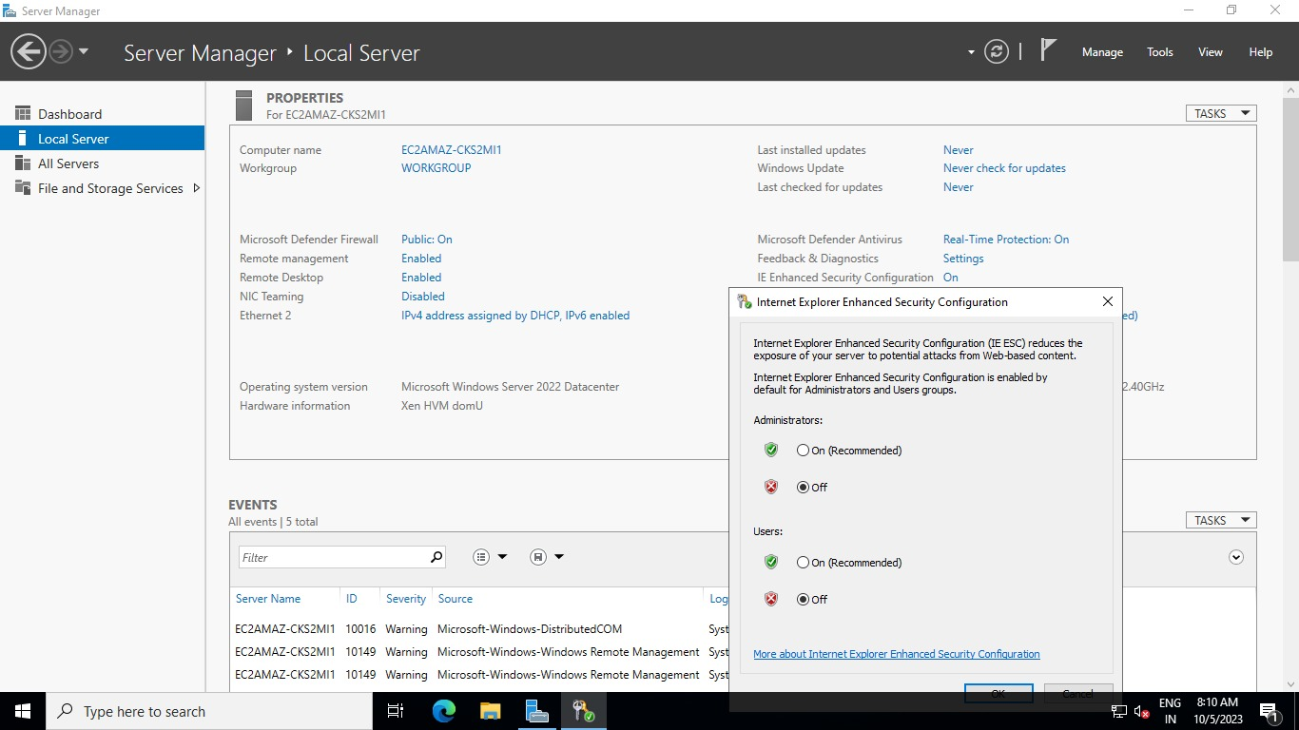



Inside server manager 🡪 local servers disable the **Internet Explorer enhanced security configuration** settings for users and administrators which is enabled by default this is done because when you will open Chrome it will ask for recommendations again and again and cause disturbance.

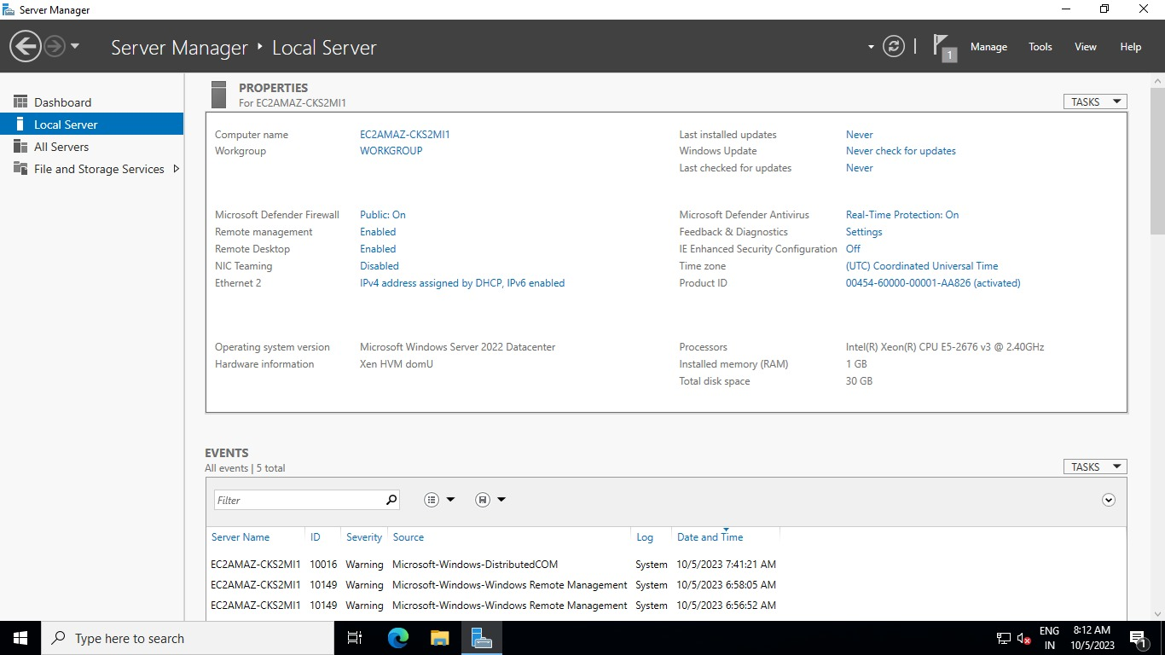

Server manager🡪local server

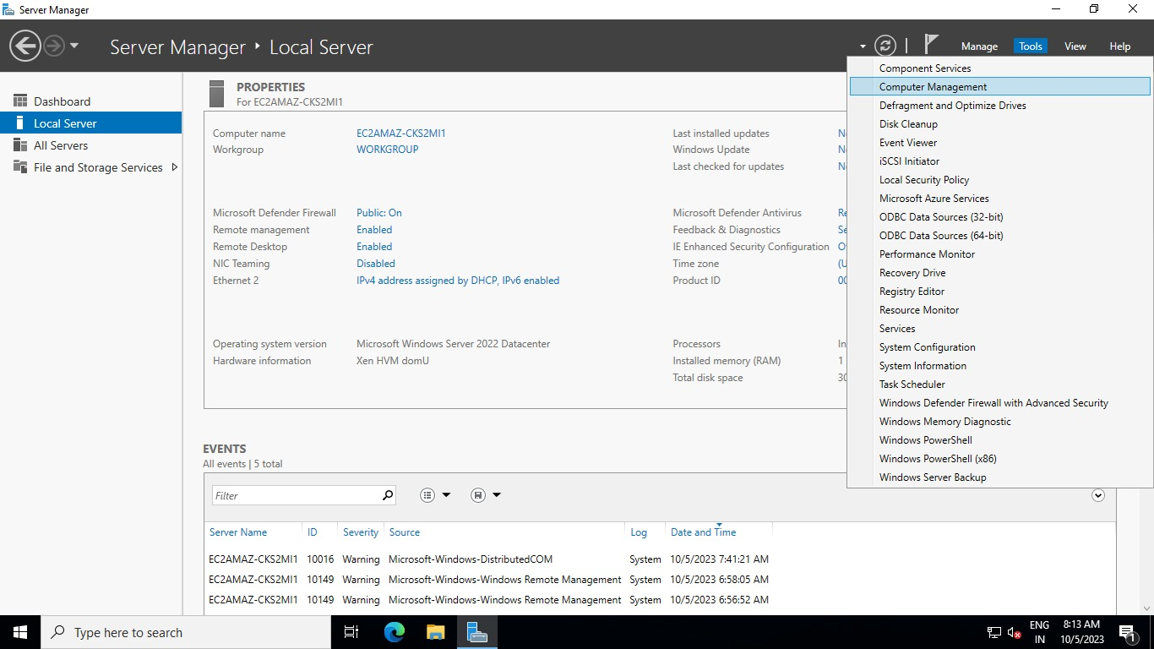

On the top right corner click on tools and select **computer management**

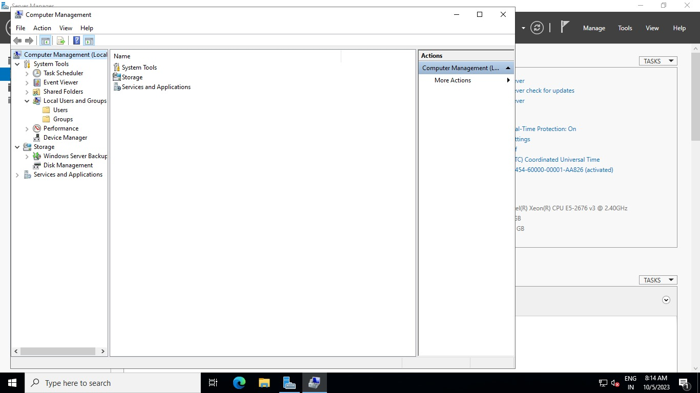

Here you can see **users and groups**

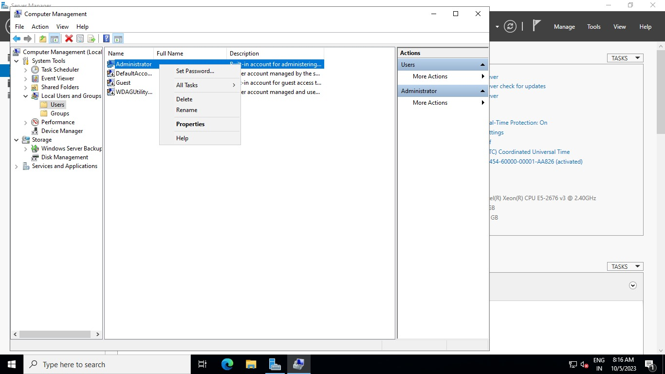

Click on users 🡪 as of now we have only one user i.e. **administrator** so right-click on administrator and you will get an option to set a password.

here the administrator’s name is given by AWS but if we need to change that Random password generated by the keypair of AWS we can set our own custom password here.

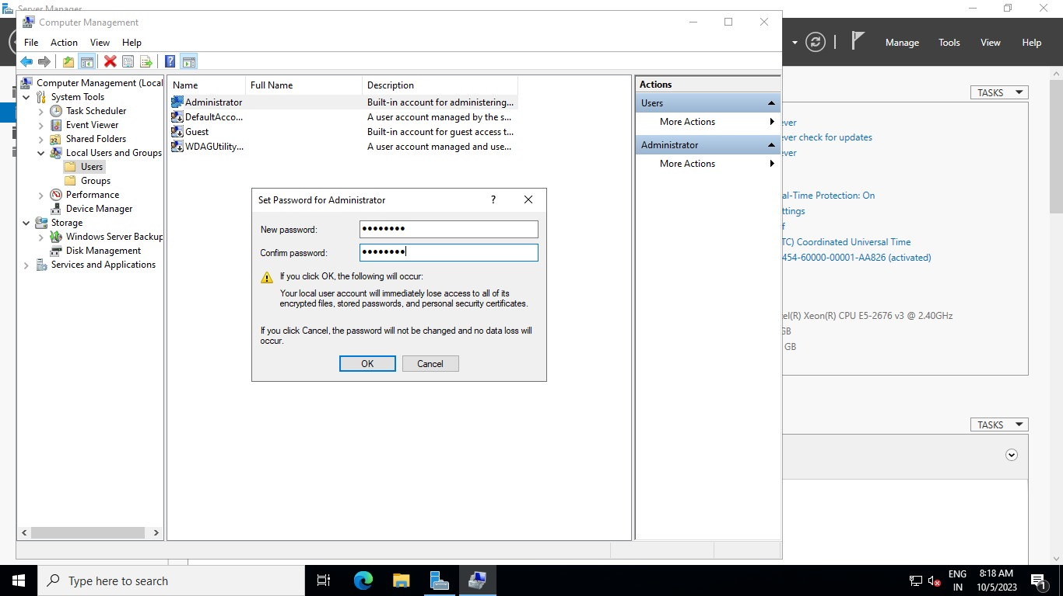

Set the new password that you want for your Windows server and confirm it by clicking OK.

Now cut the remote desktop window and try to login again for testing.

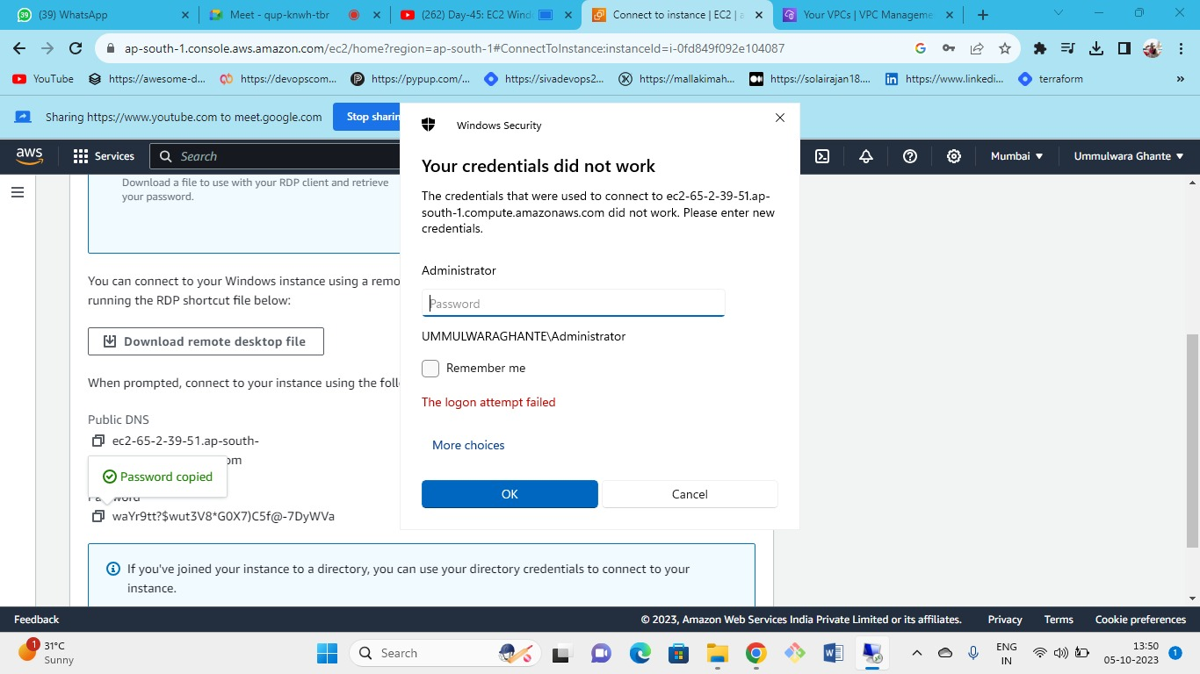



As you can see our login attempt failed when we tried to log in with the random password which is provided by AWS because we have now set our own new custom password so try to log in from the new password to the administrator.

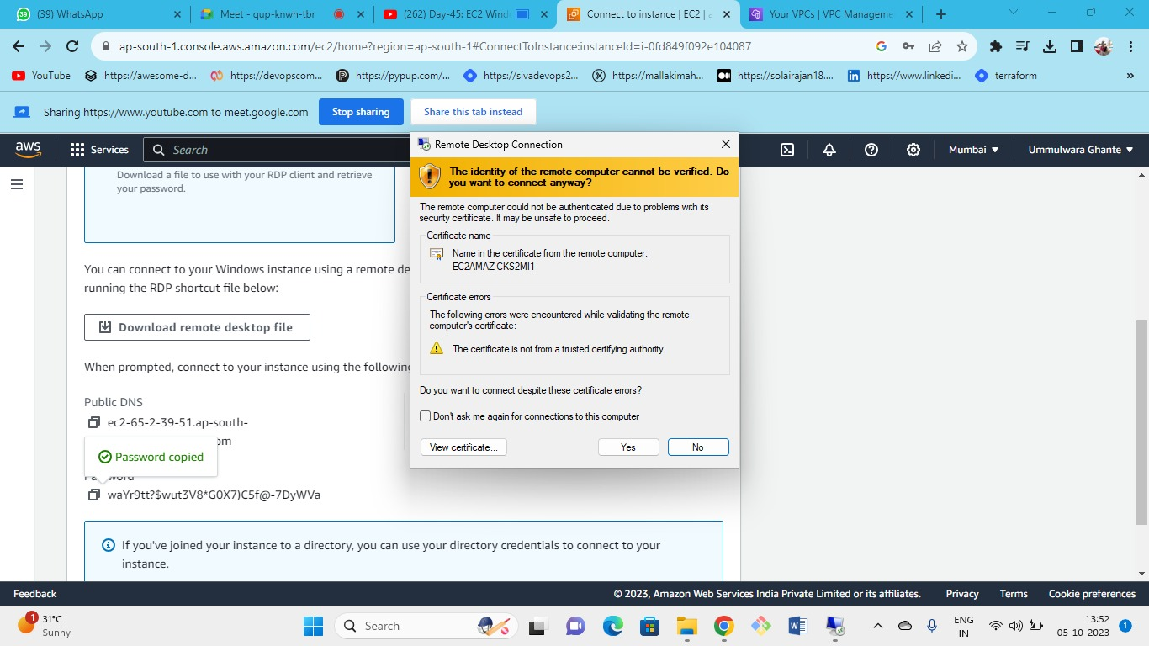



As you can see our login is successful when we logged in from the custom password that we have set

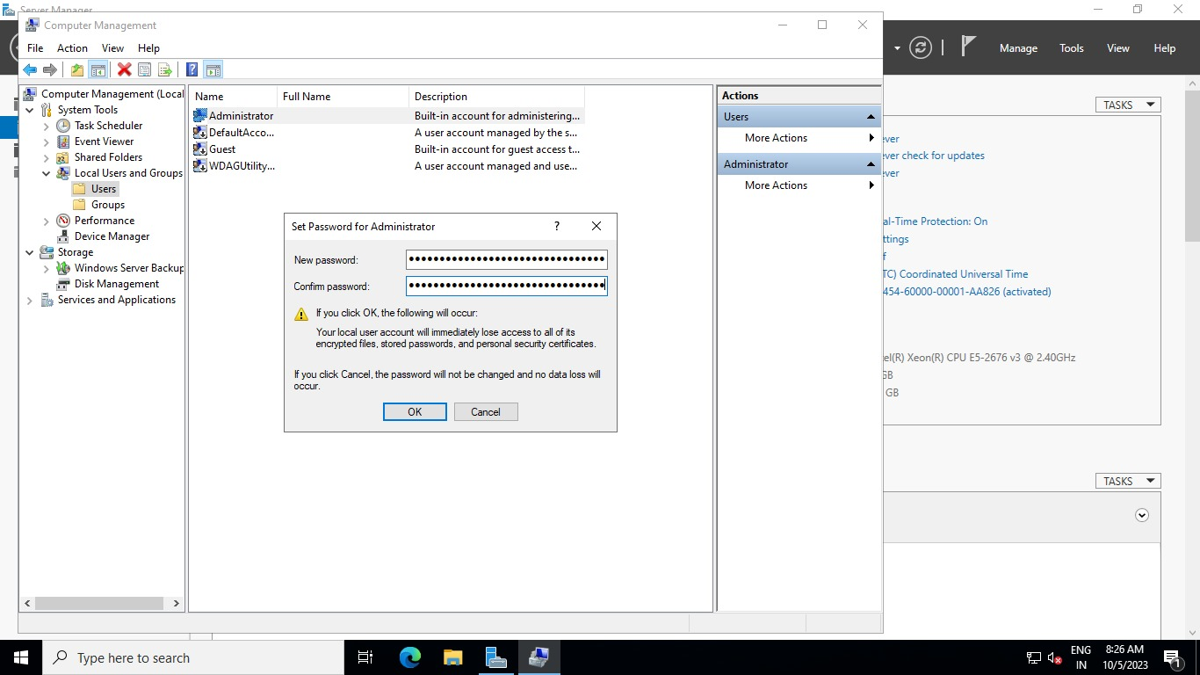

Now again if you want the same random password that was earlier provided by the AWS you can reset it by repeating the same steps

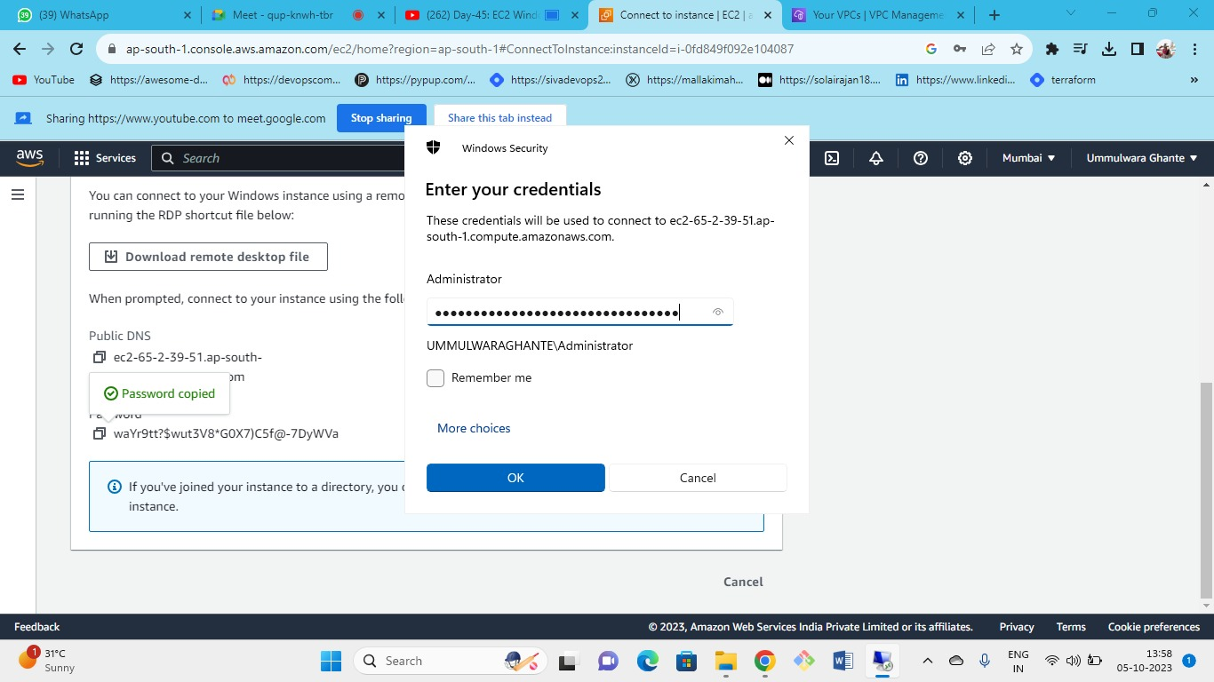



After resetting you can try to login from the random password of AWS

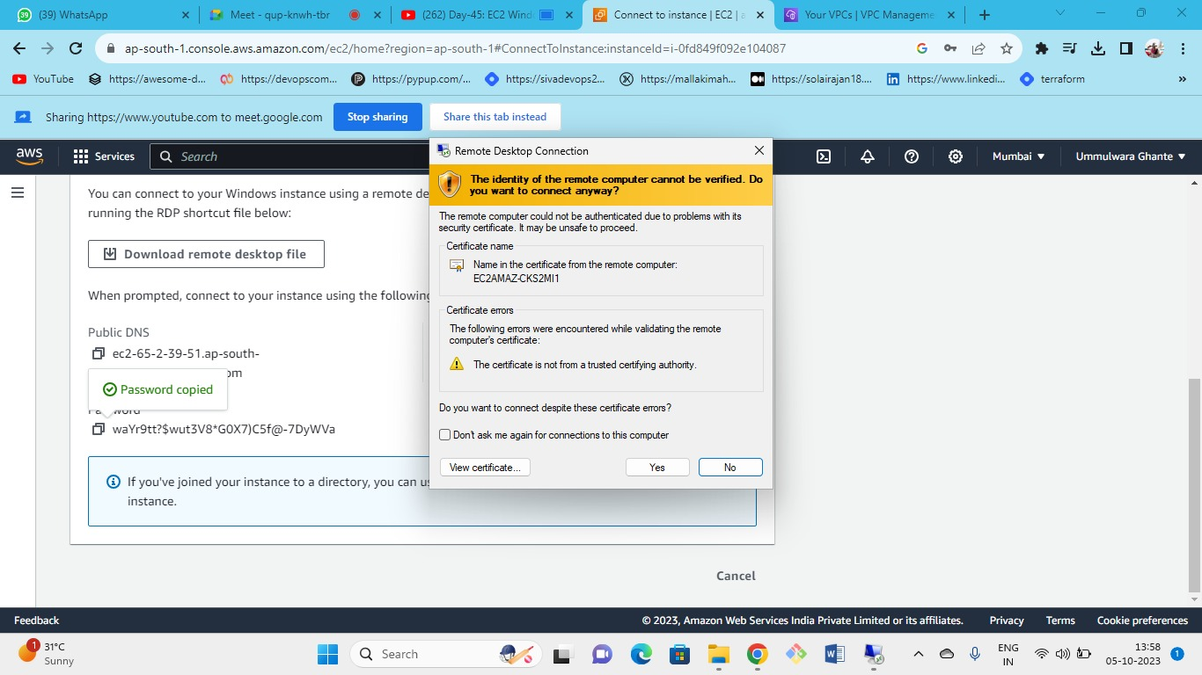



again, with a random password login to the server is successful

As we have seen earlier, we have just one user i.e. administrator so lets create a new user

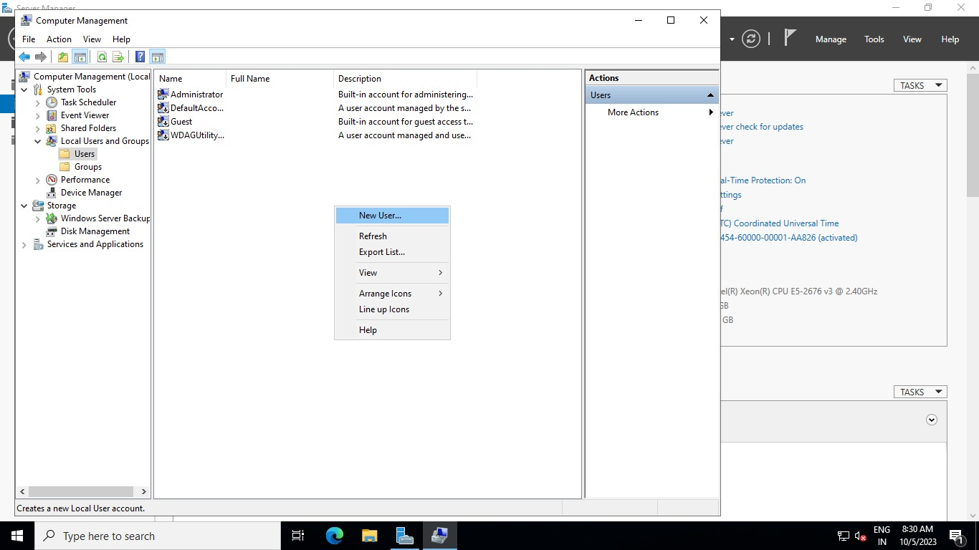

By just clicking on users and right-clicking here you can create new user too.

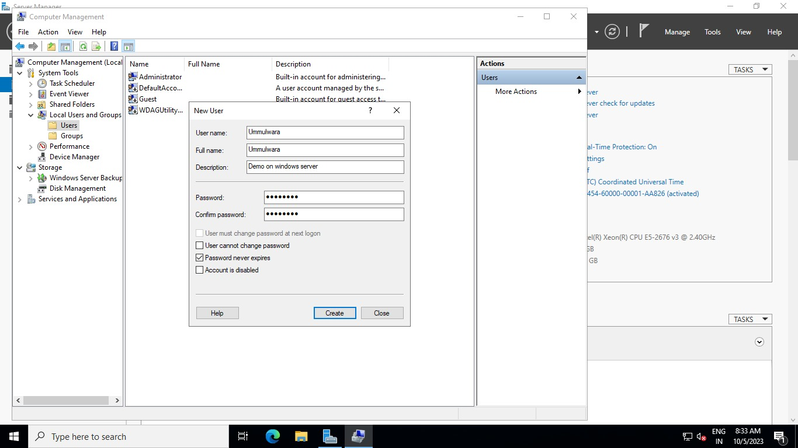



Fill in the necessary details of the user such as username, name, password, and confirmation password also untick the checkbox of user cannot change password and tick the option of password never expire

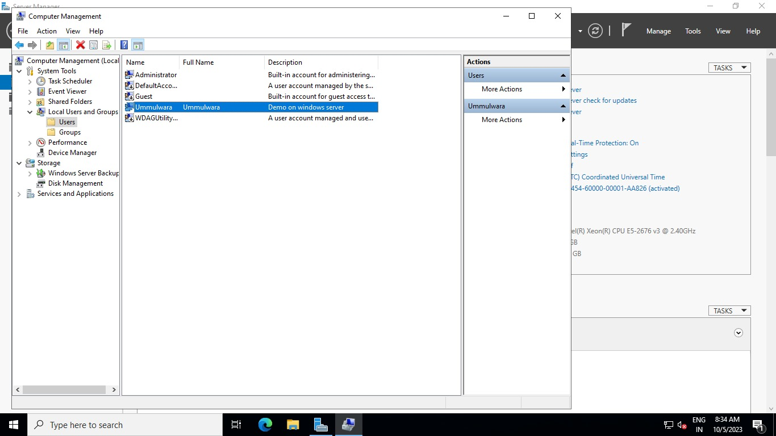

As you can see our new user has been created successfully

Now just check by logging in as new user so open the new RDP window to login to the user

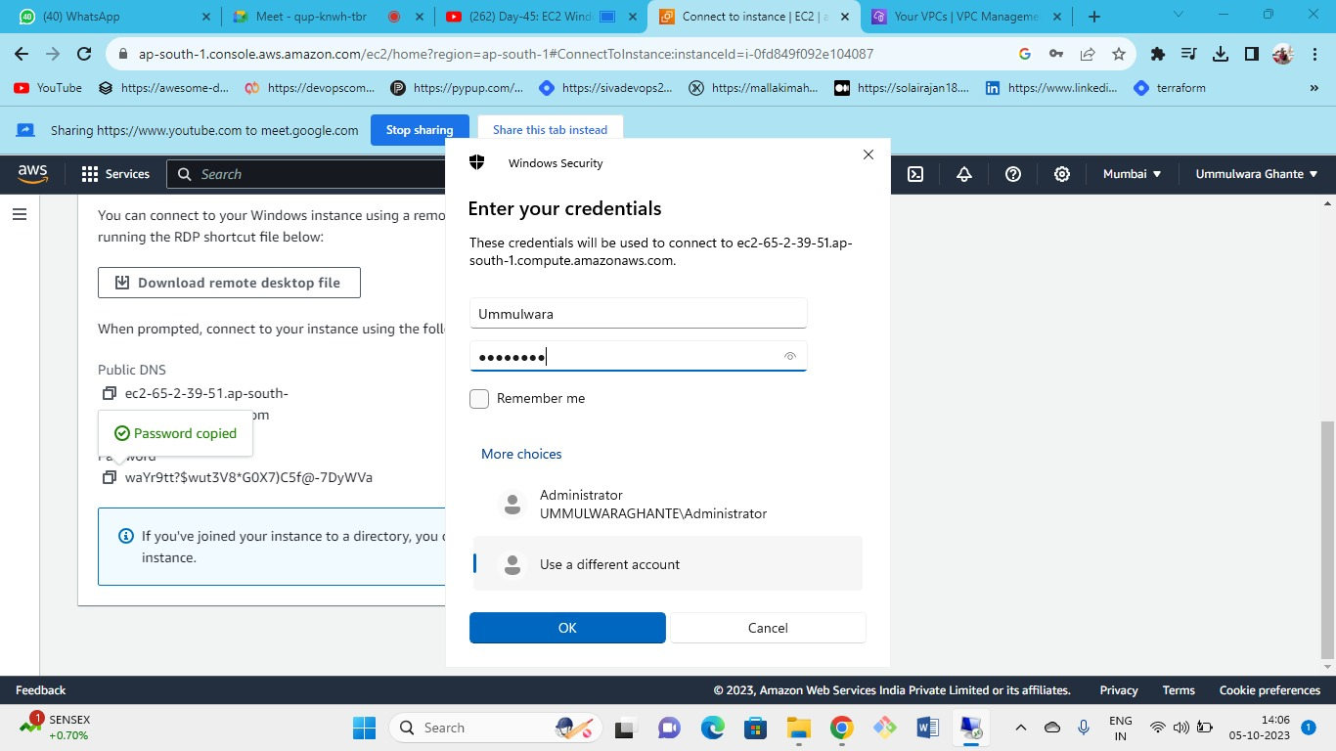



Write the user name and password which you have created just now.

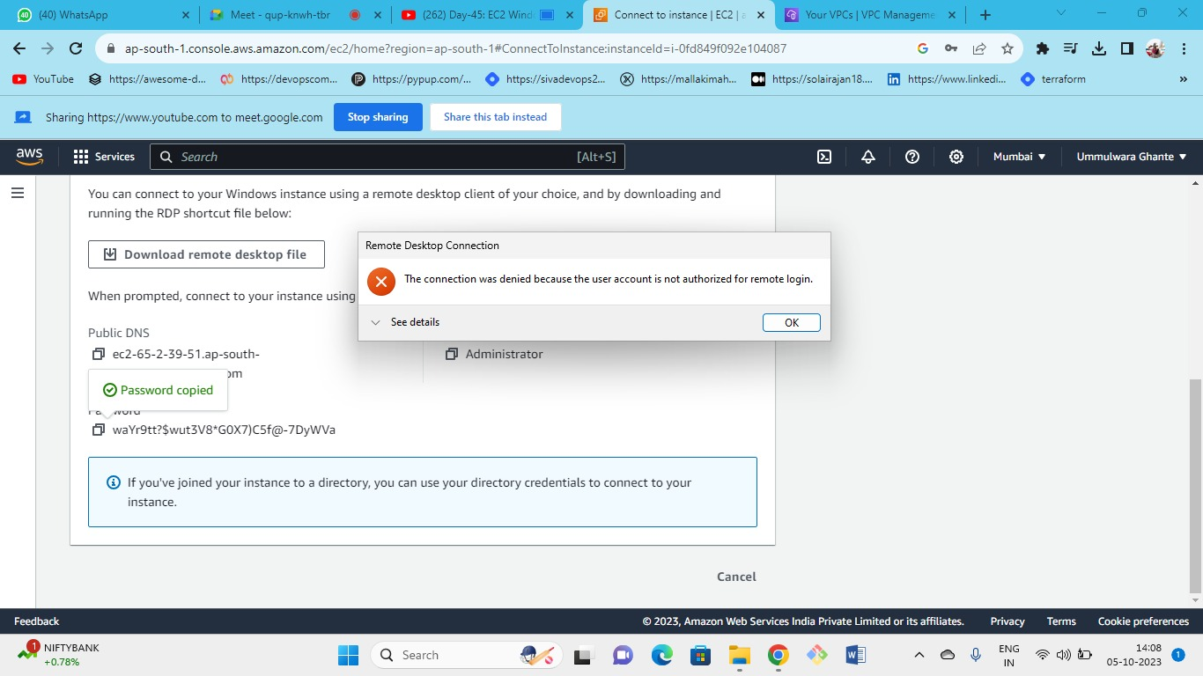



As you can see we will get the following error while logging in from the newly created user because the newly created user doesn’t have permission for remote login so to give the user access again login as administrator into the windows server

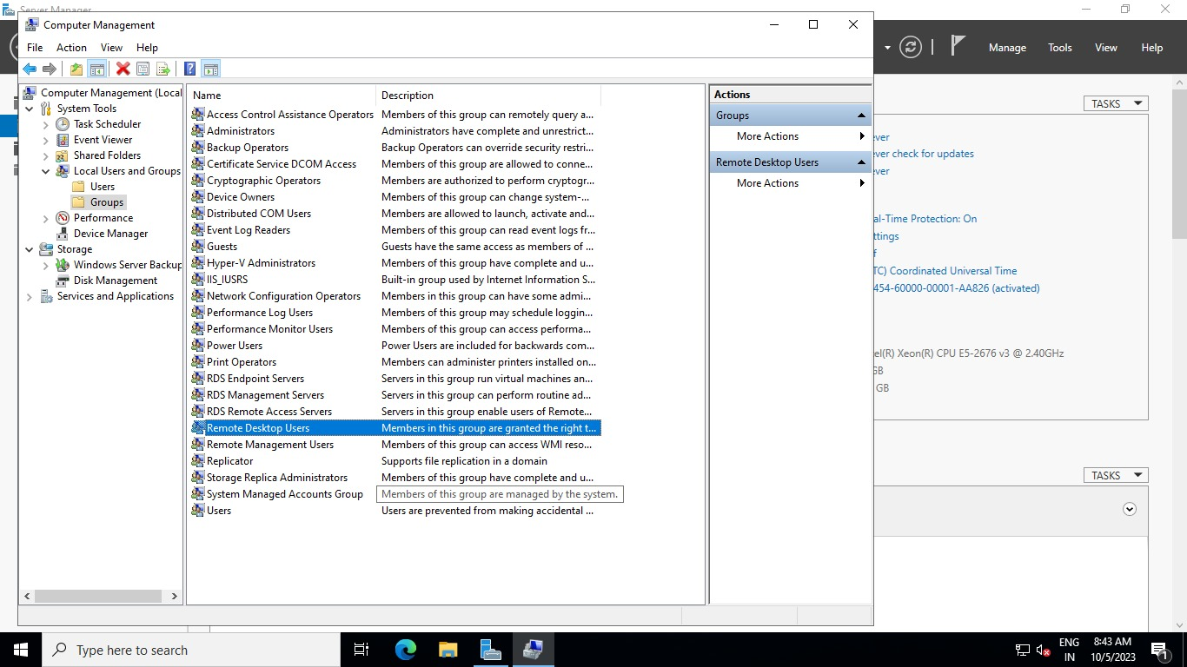

Groups🡪 remote desktop users

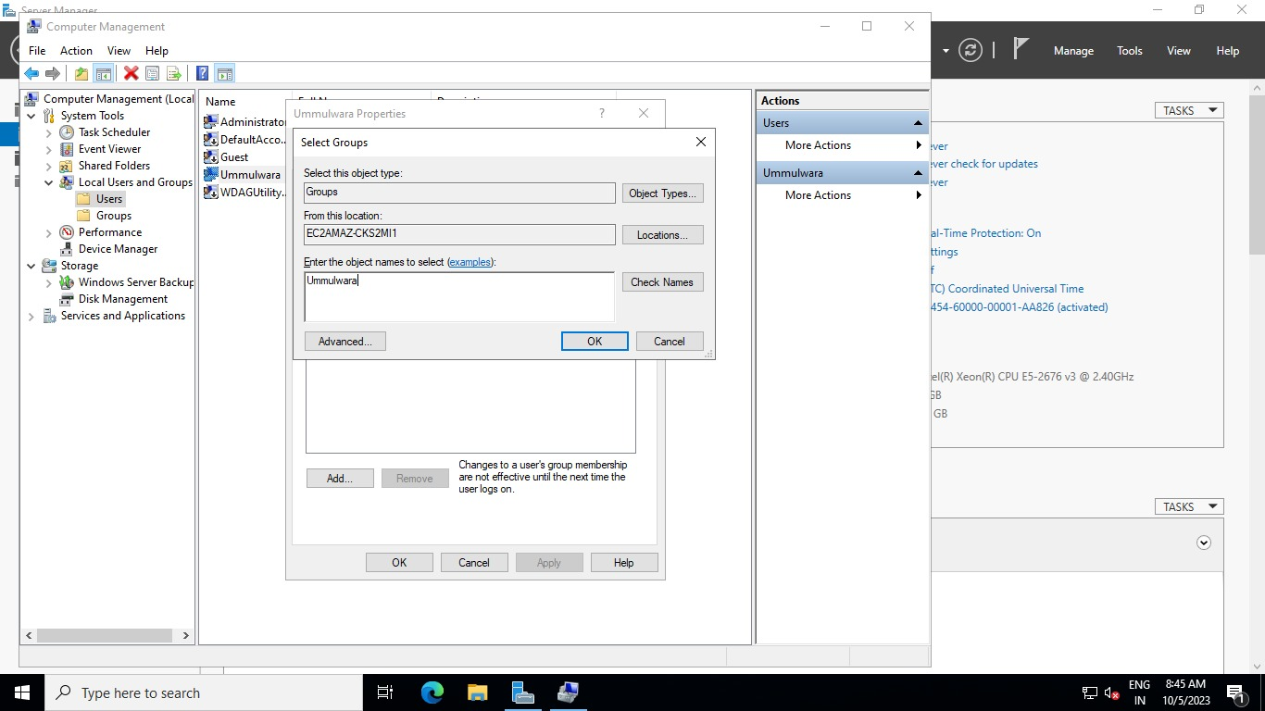

Just add the username and check its valid 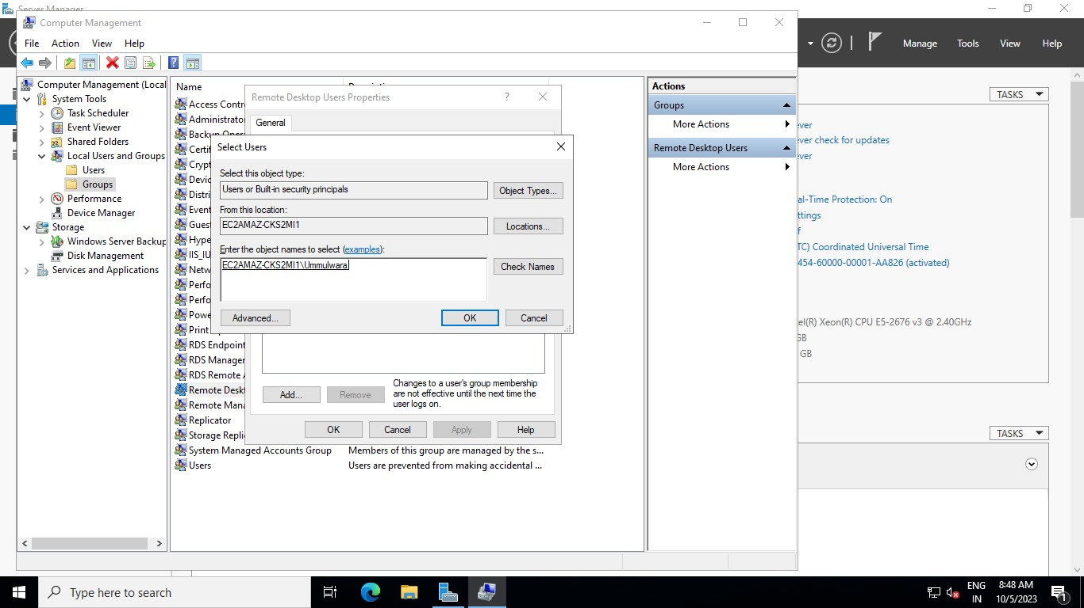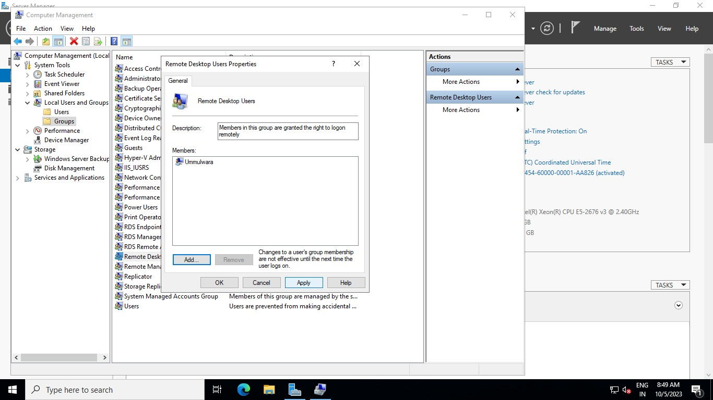

Click on apply

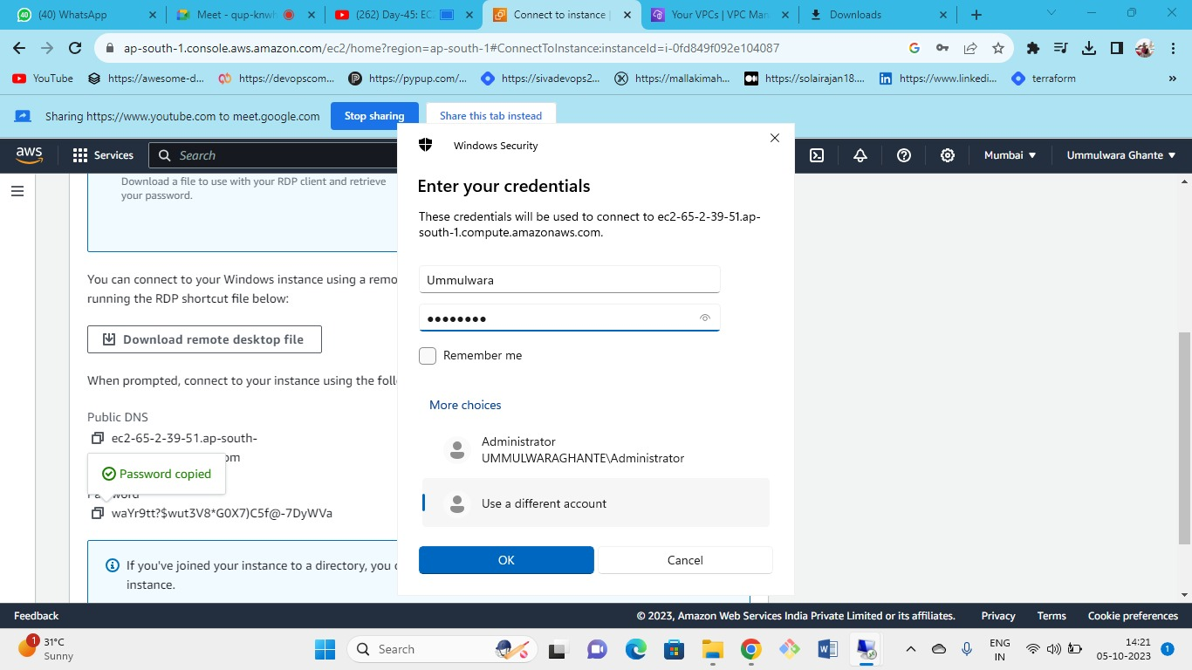



Now try to login the Remote desktop from the new user

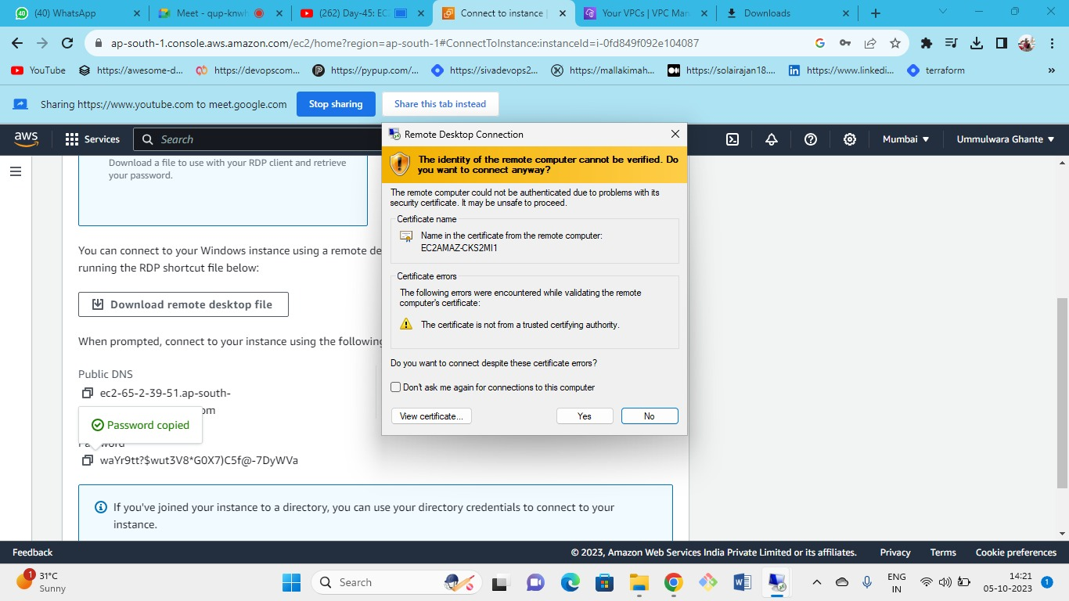



As we can see we are able to successfully able to login

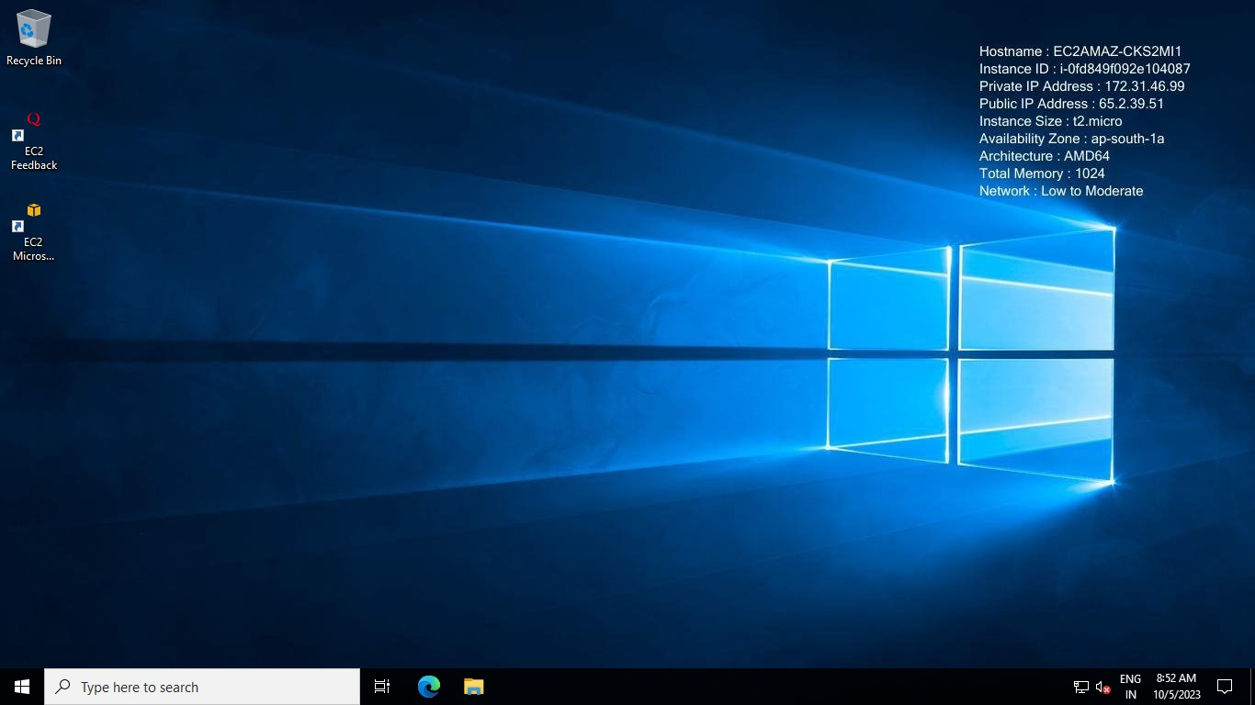

you have successful login from both the user.

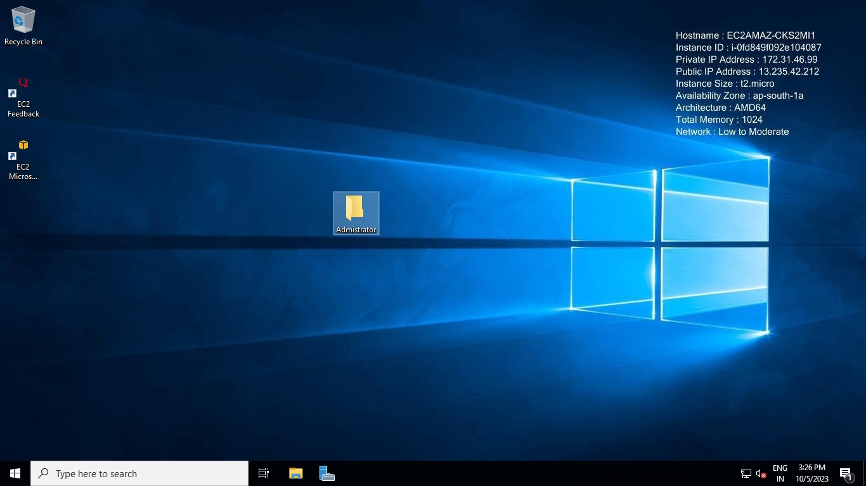

Here in administrator server we have created one folder named as **ADMINISTRATOR**

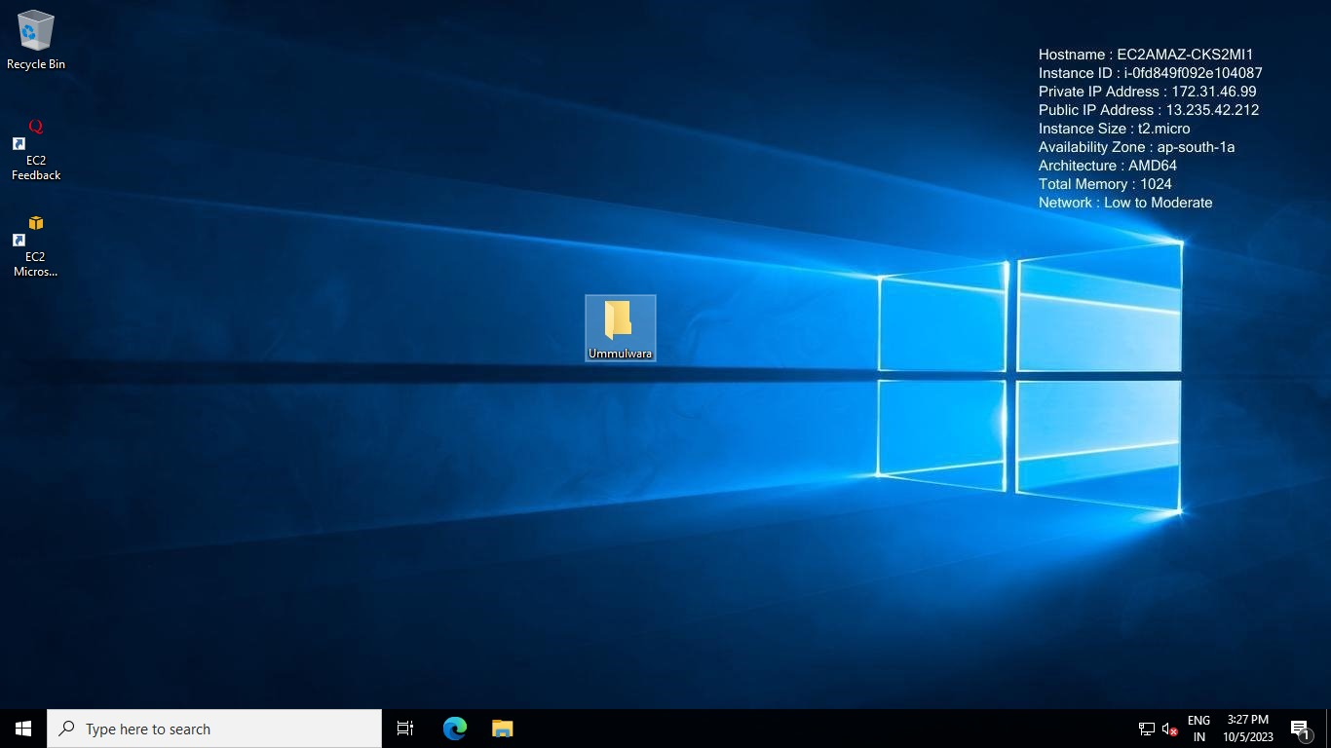

In the created user server we have created one folder named as Ummulwara

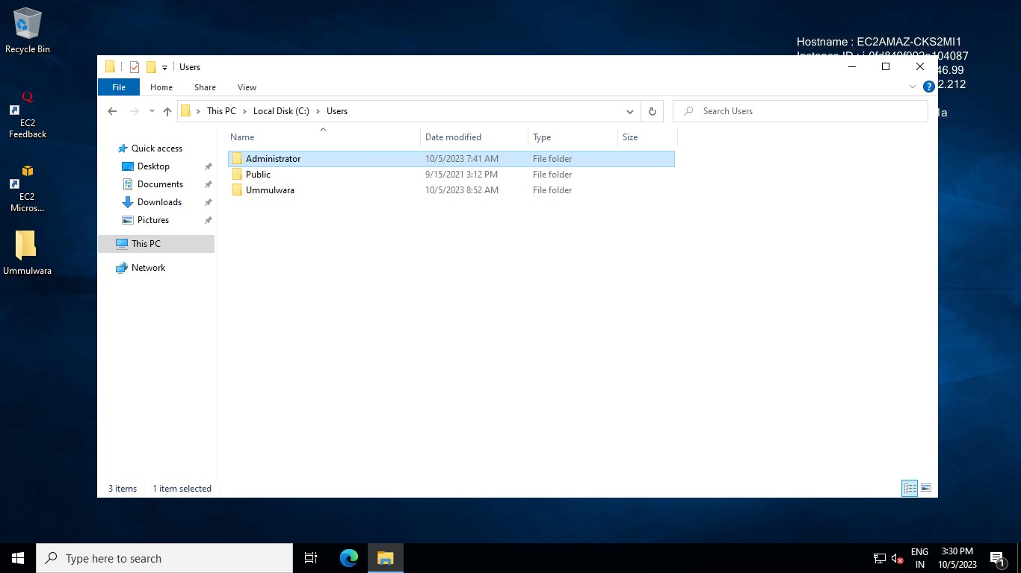

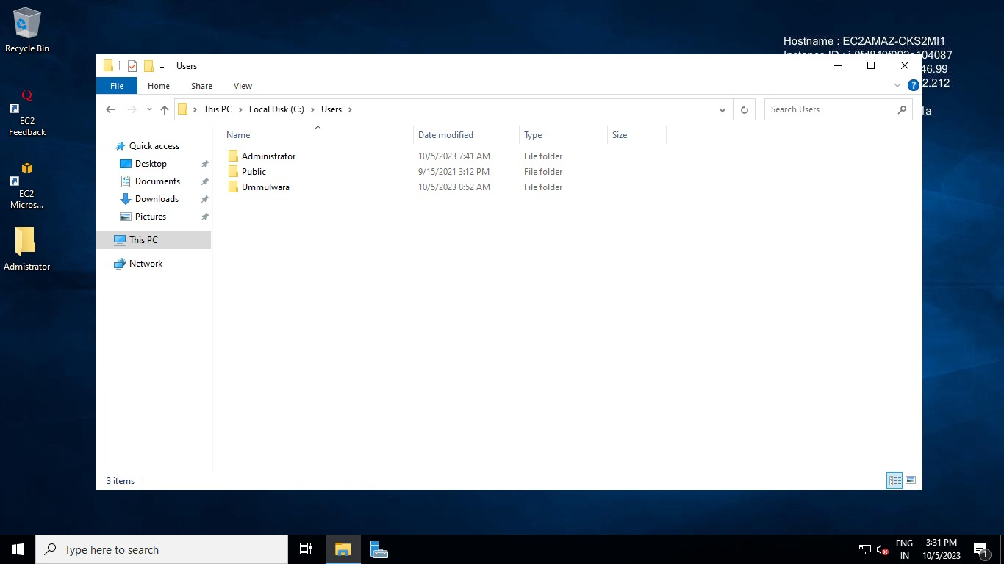

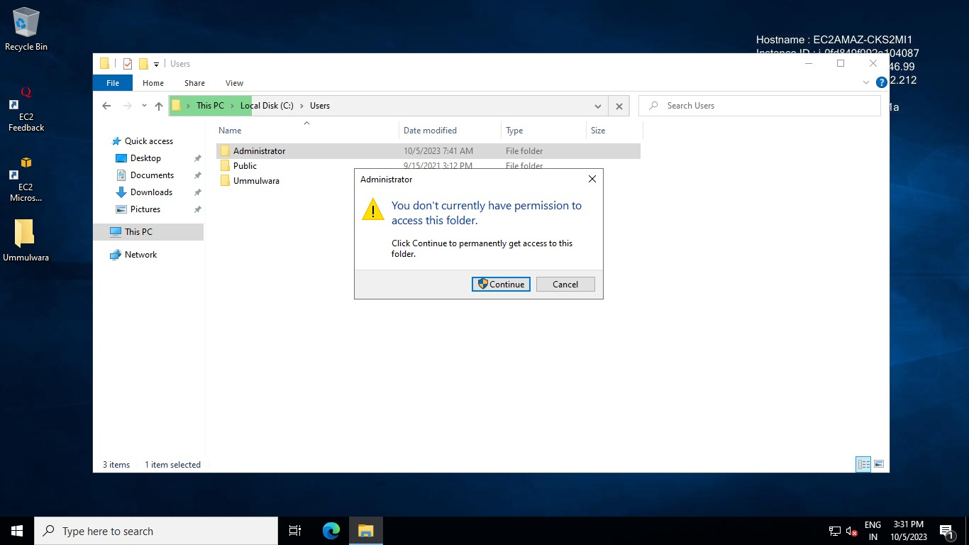

New user cannot access administrator server as it requires permission/password

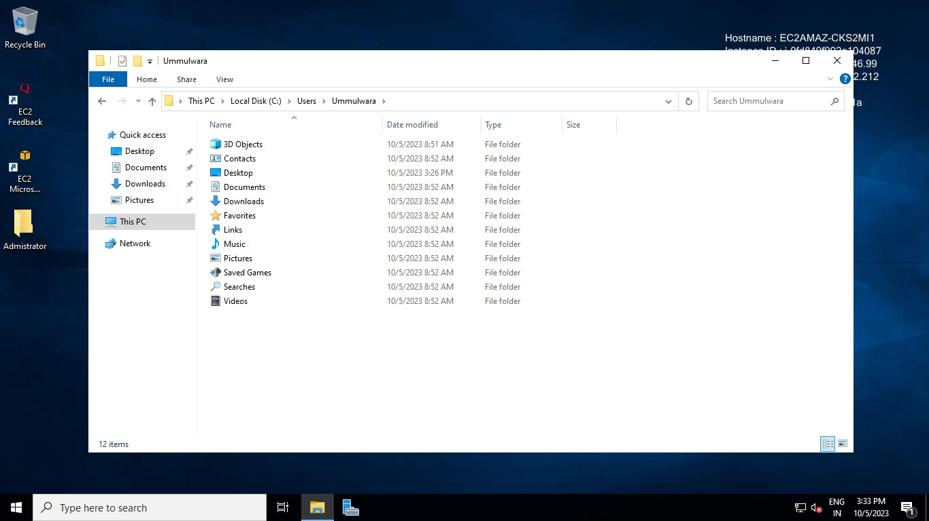

* Only 2 RDPs are possible for 2 users (admin, Ummulwara) to simultaneously connect with free Windows if you need more than 2 RDPs simultaneously you need to purchase paid features for Windows
* Single user can have 1 RDP session. (admin, Ummulwara, Ummulwara) as one user cannot have same RDP session at a time.



* If you want more RDPs you need to purchase a license from Microsoft known as a client access license or CAL.
* At a time, you can have two connections with the same user.
* Now create a new Windows Server 2 and keep the default settings as first

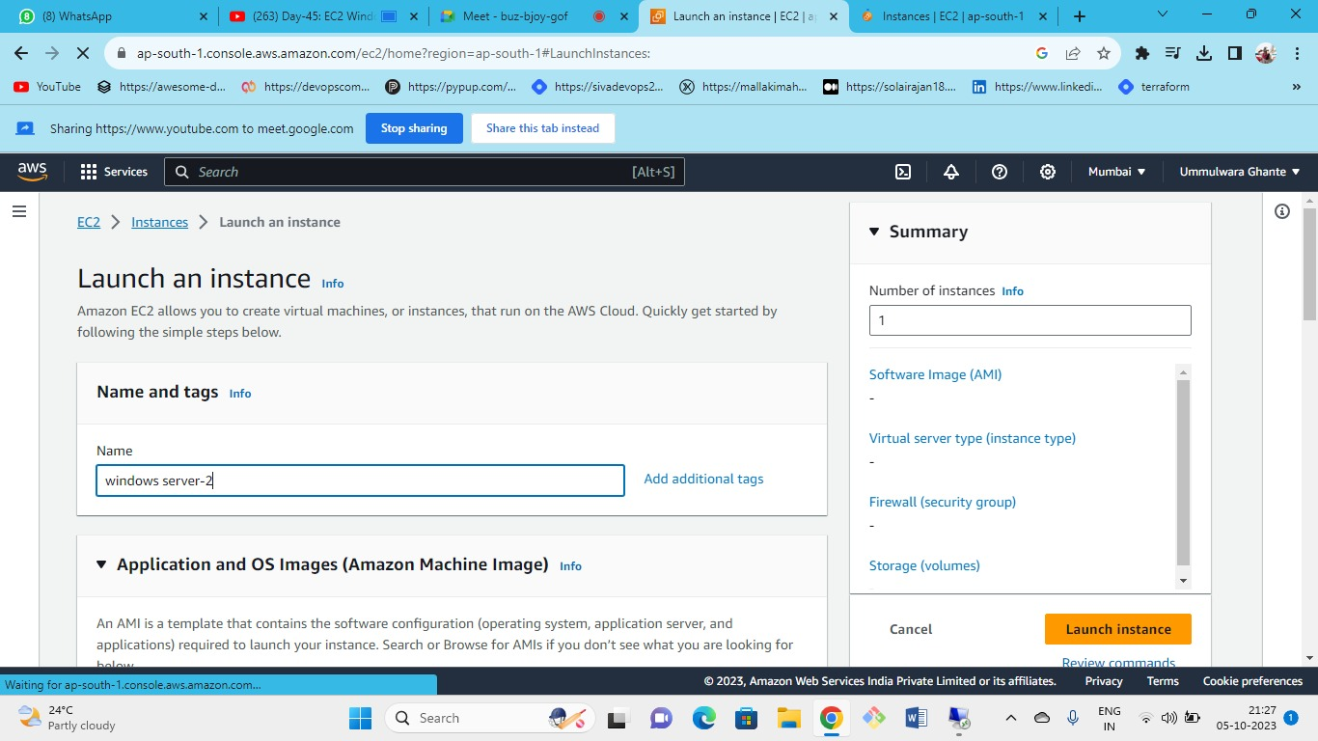



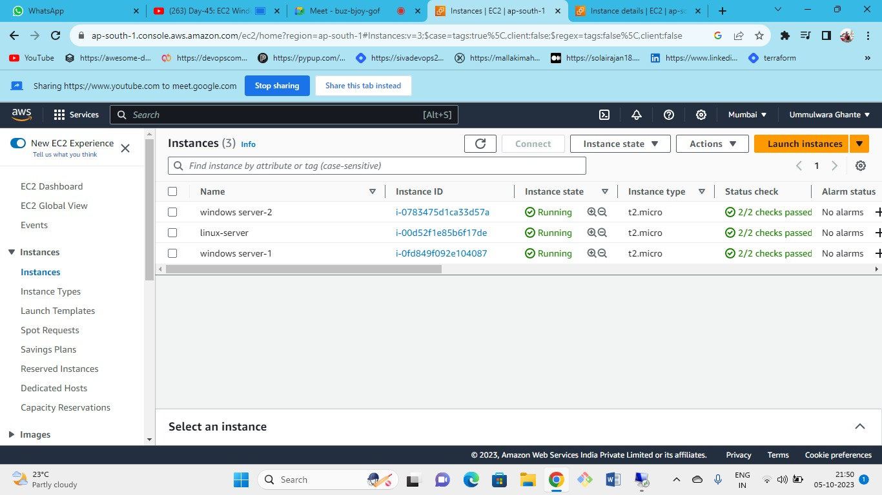



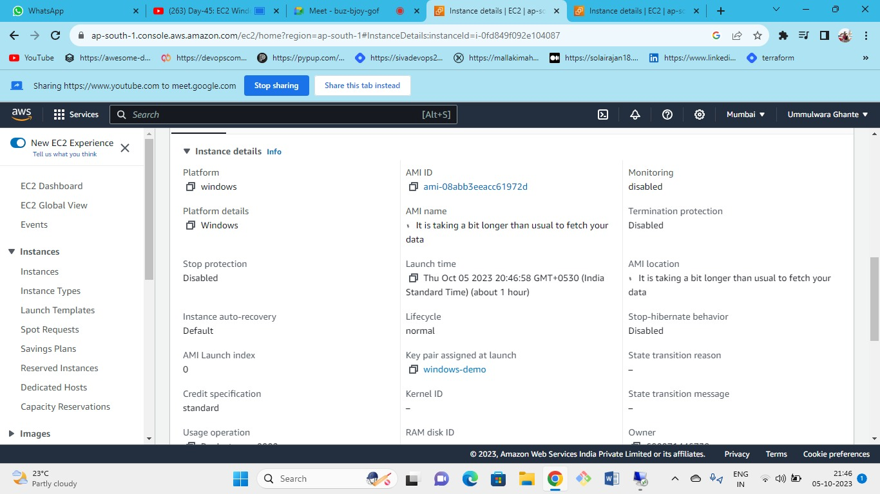



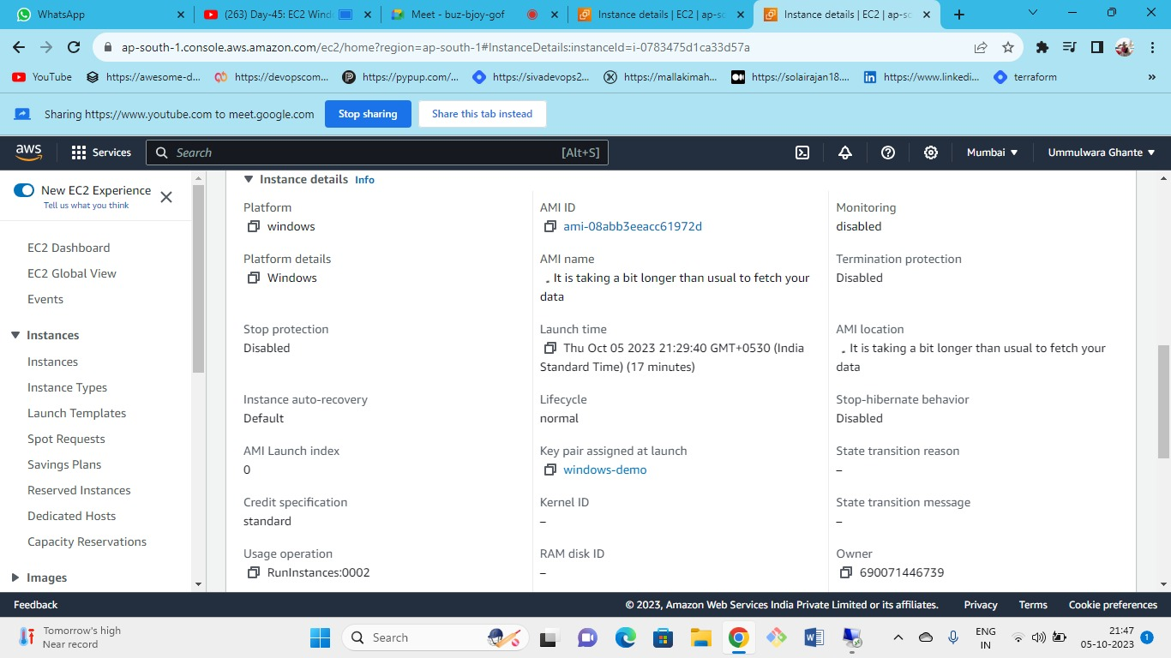Both EC2 windows server has been launched with the same key pairs



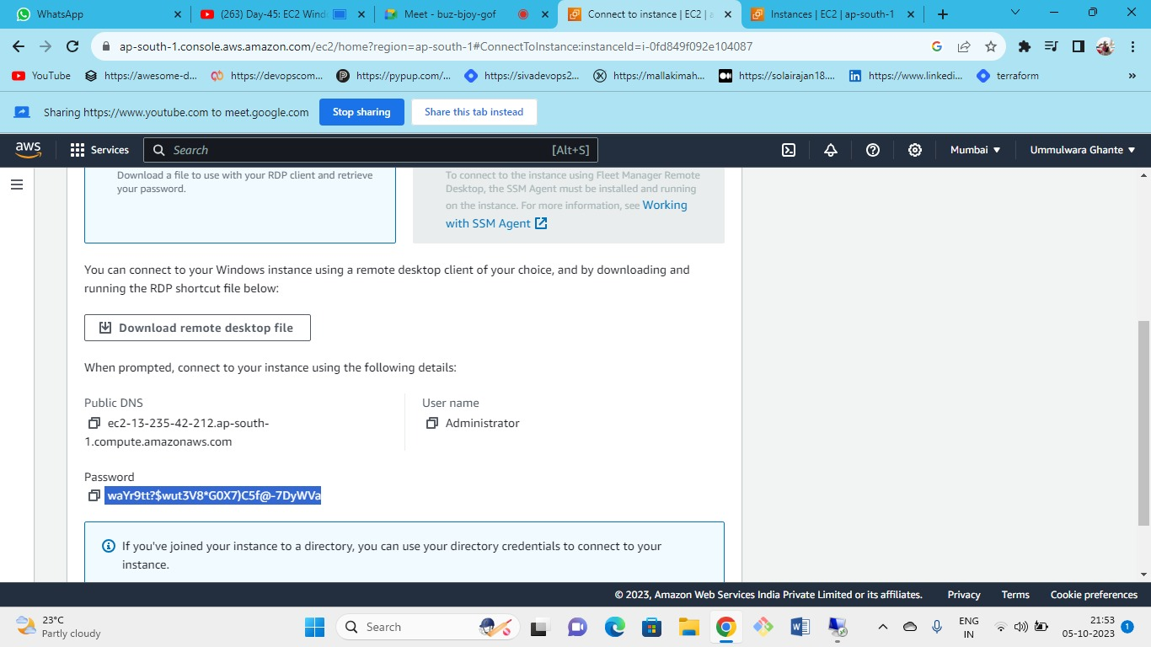This is the password for the Windows 1 server



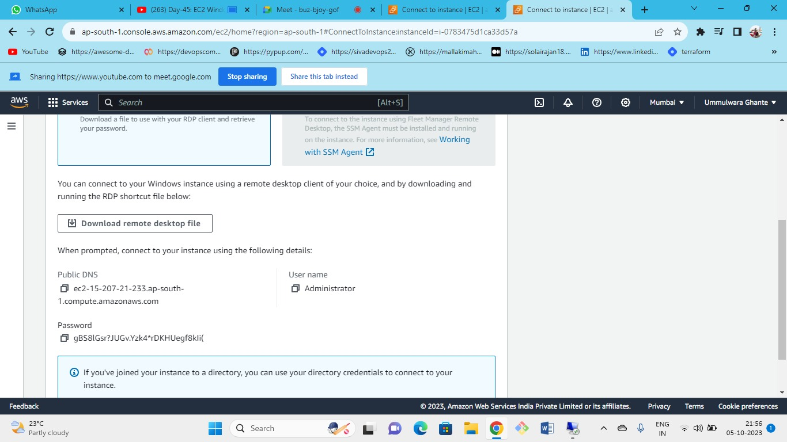



Following is the decrypted password for Windows 2

We have applied the same key pair for both the ec2 instances but the password retrieved is different for both instances.

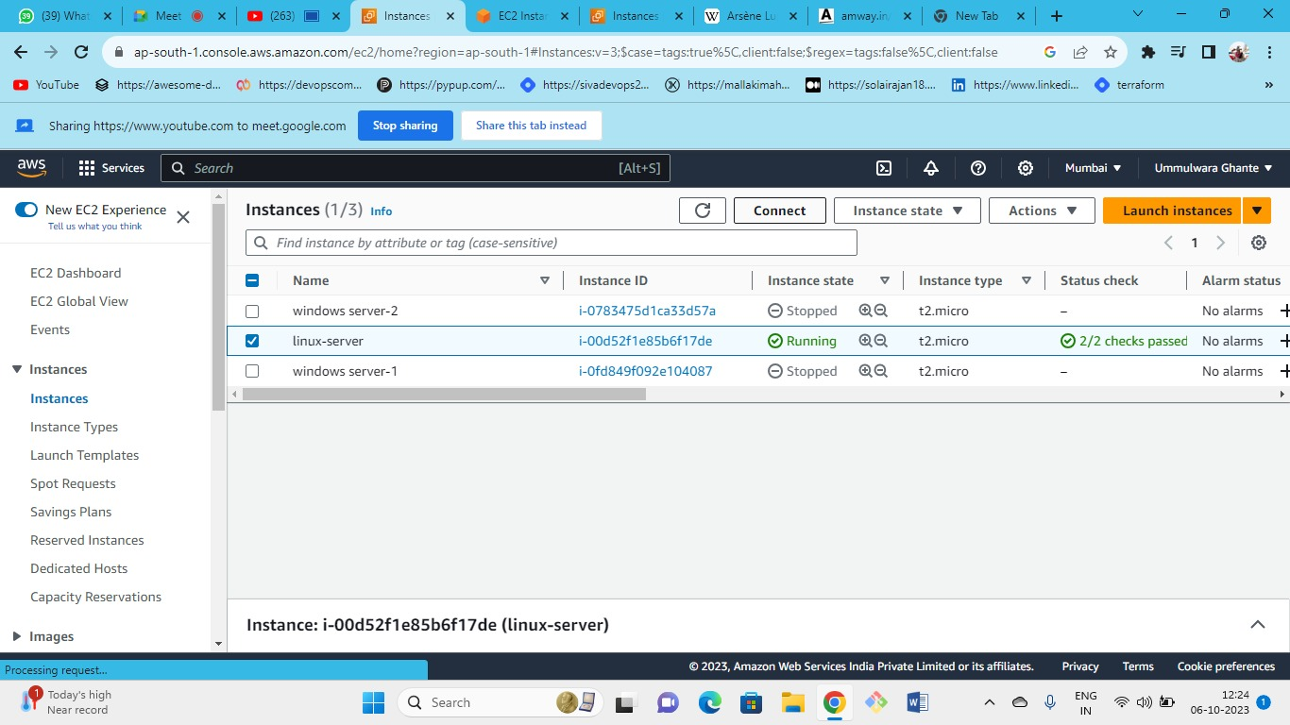



connect to linux server

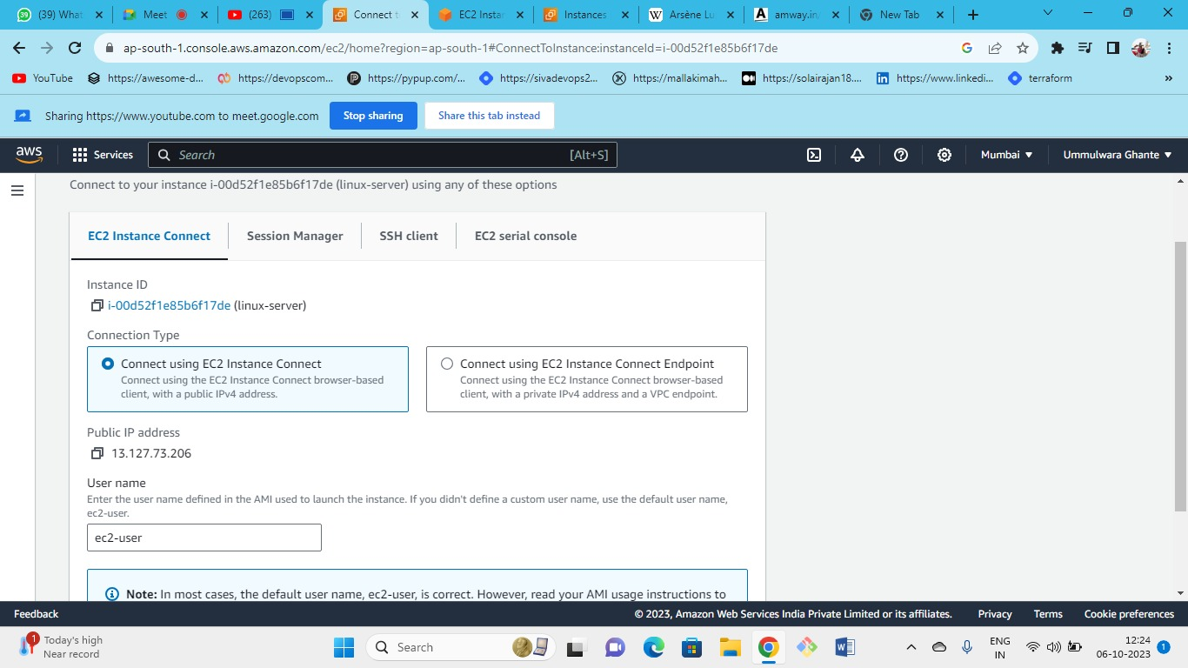



through ec2 instance connect.

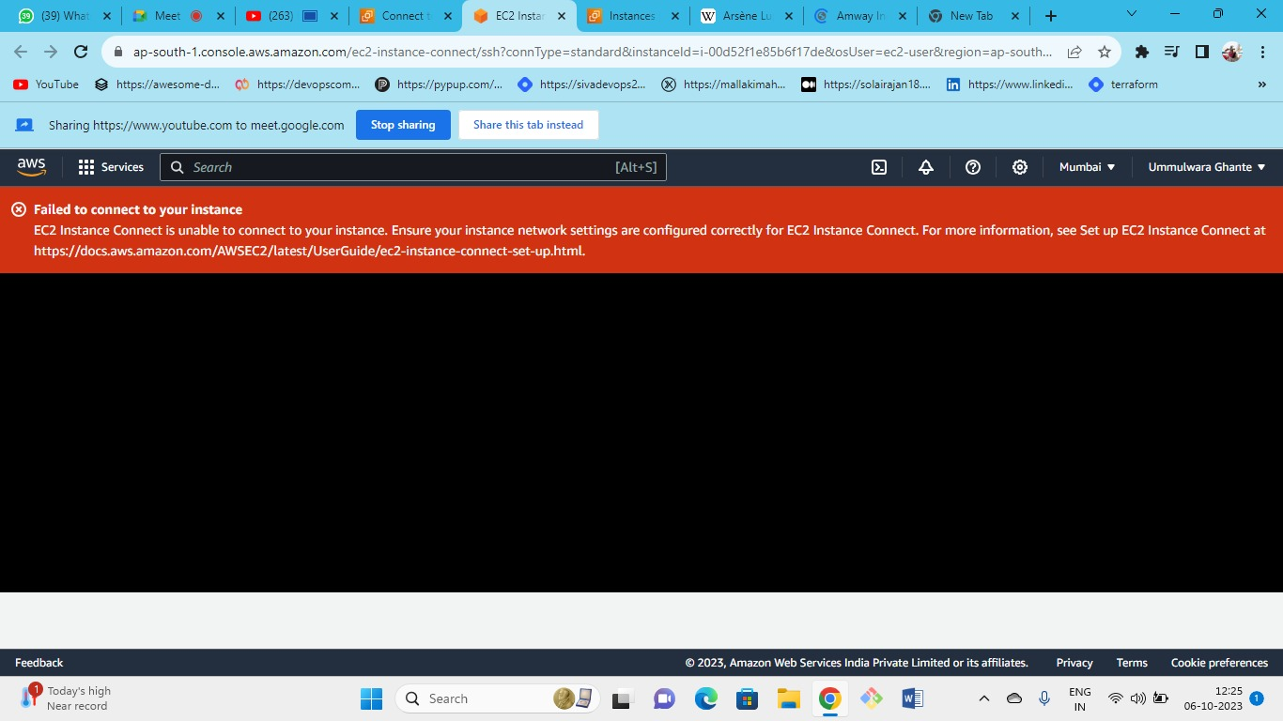



When we try to connect we came across with an error

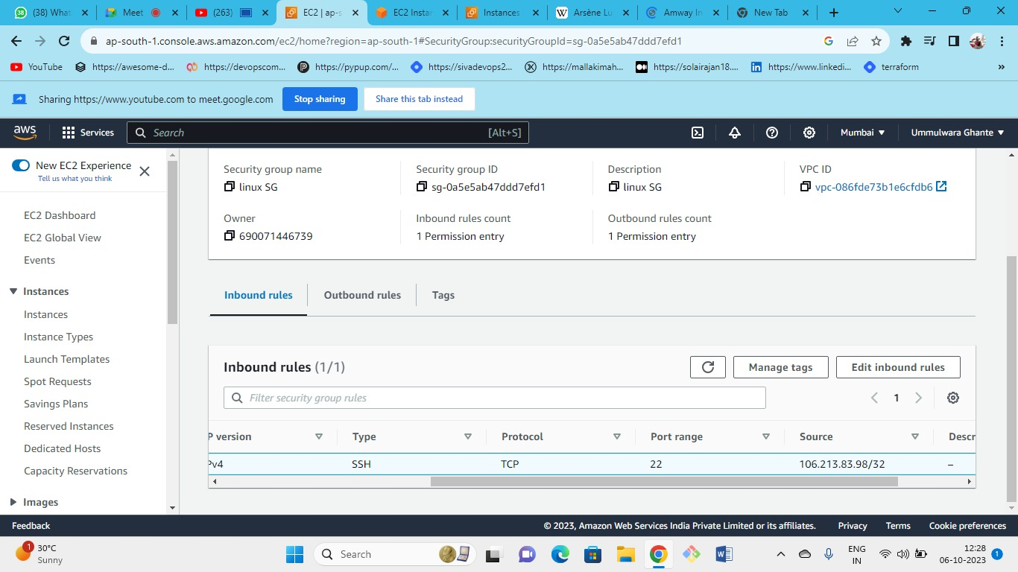



As port 22 is open for my IP

as there is a limitation for ec2 connect as you need to open Port 22 for anywhere

Note – This is not a good practice

As we need to connect a client to a server, we use putty so in this case AWS is managing that for us in the backend, as AWS has some servers which helps to manage all this.

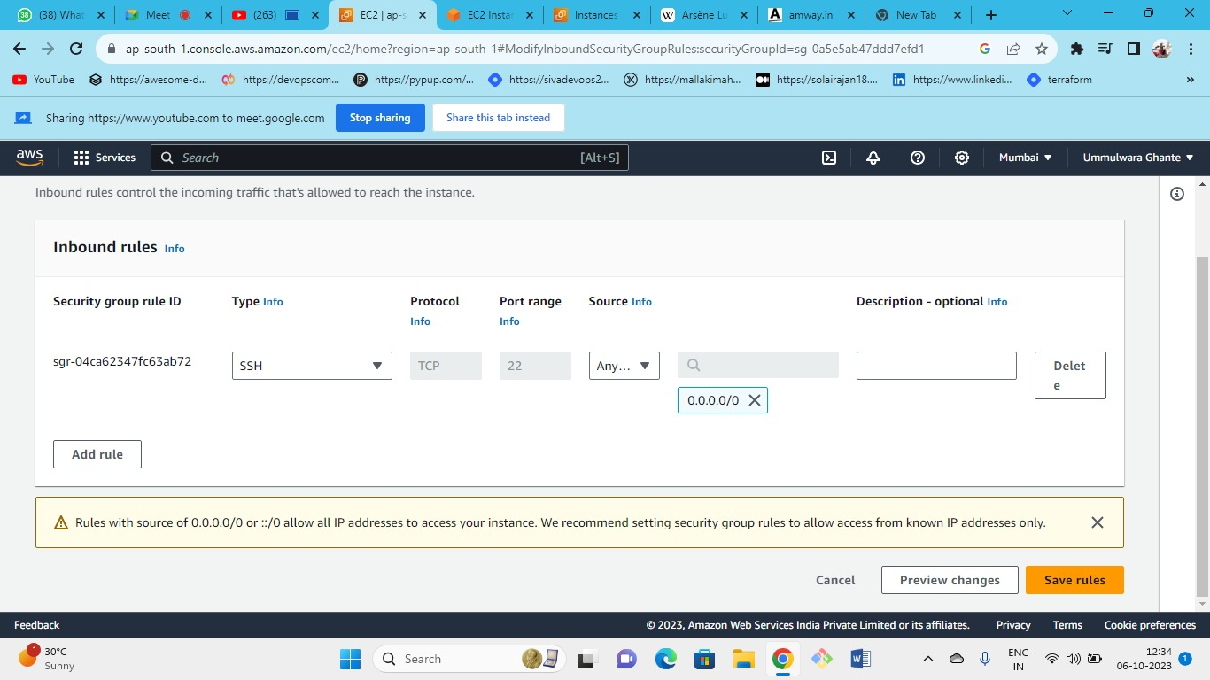



just change the source to anywhere

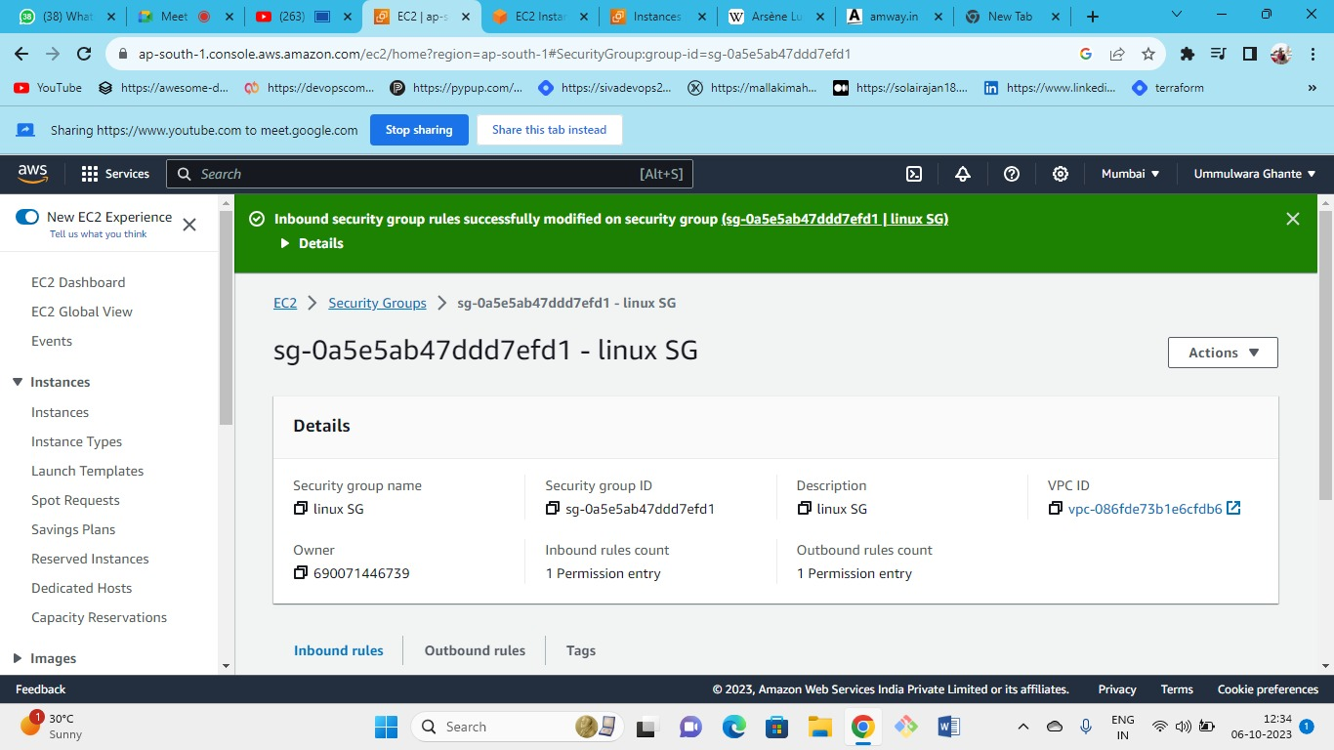



save the rule

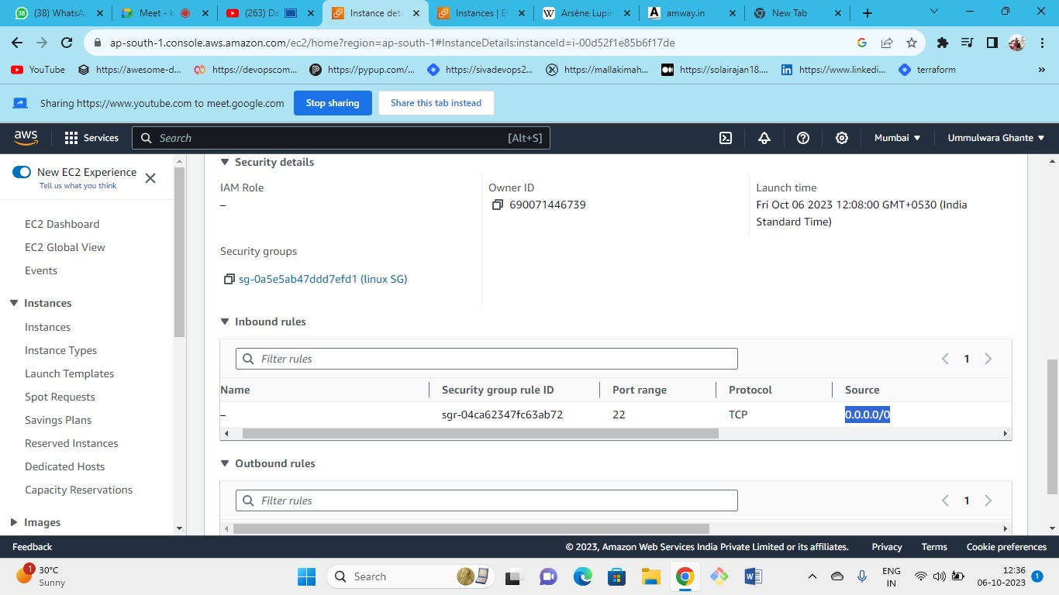



now connect the server again

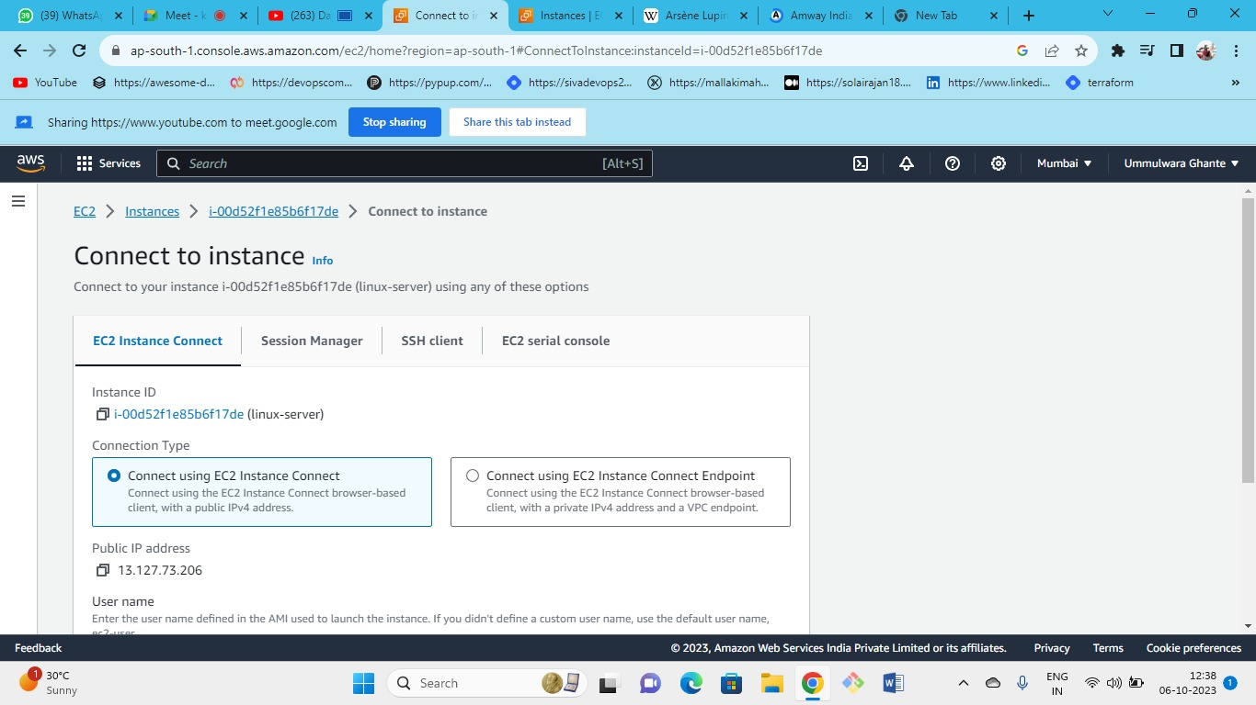



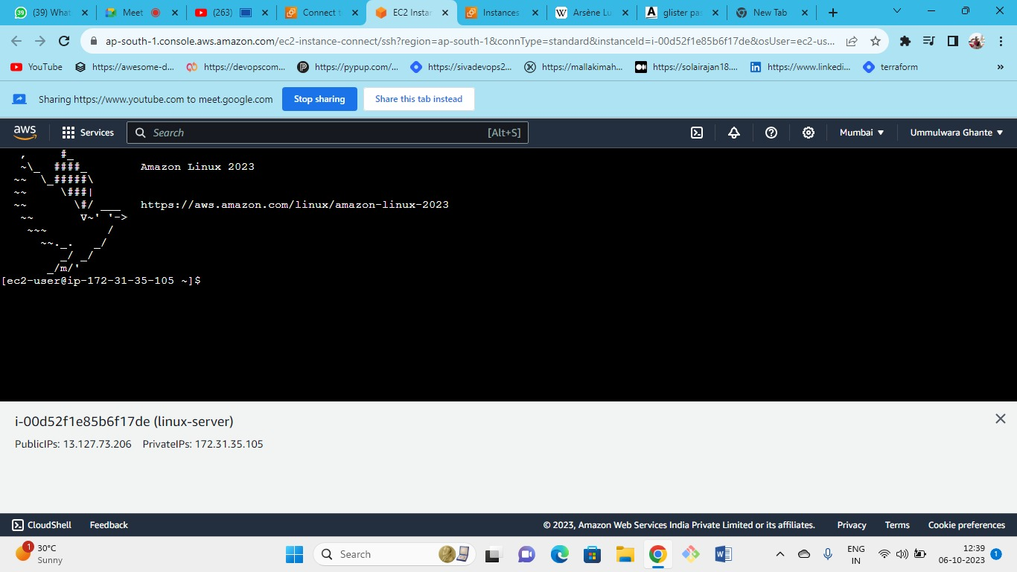



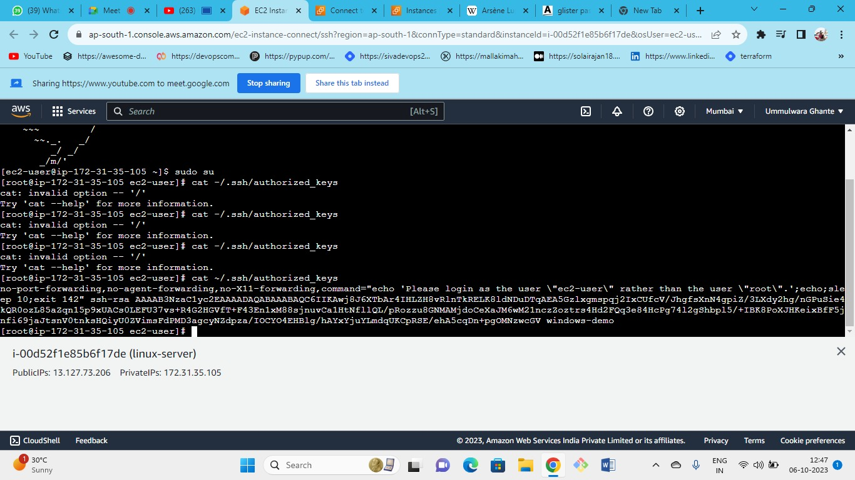



All keys are visible here

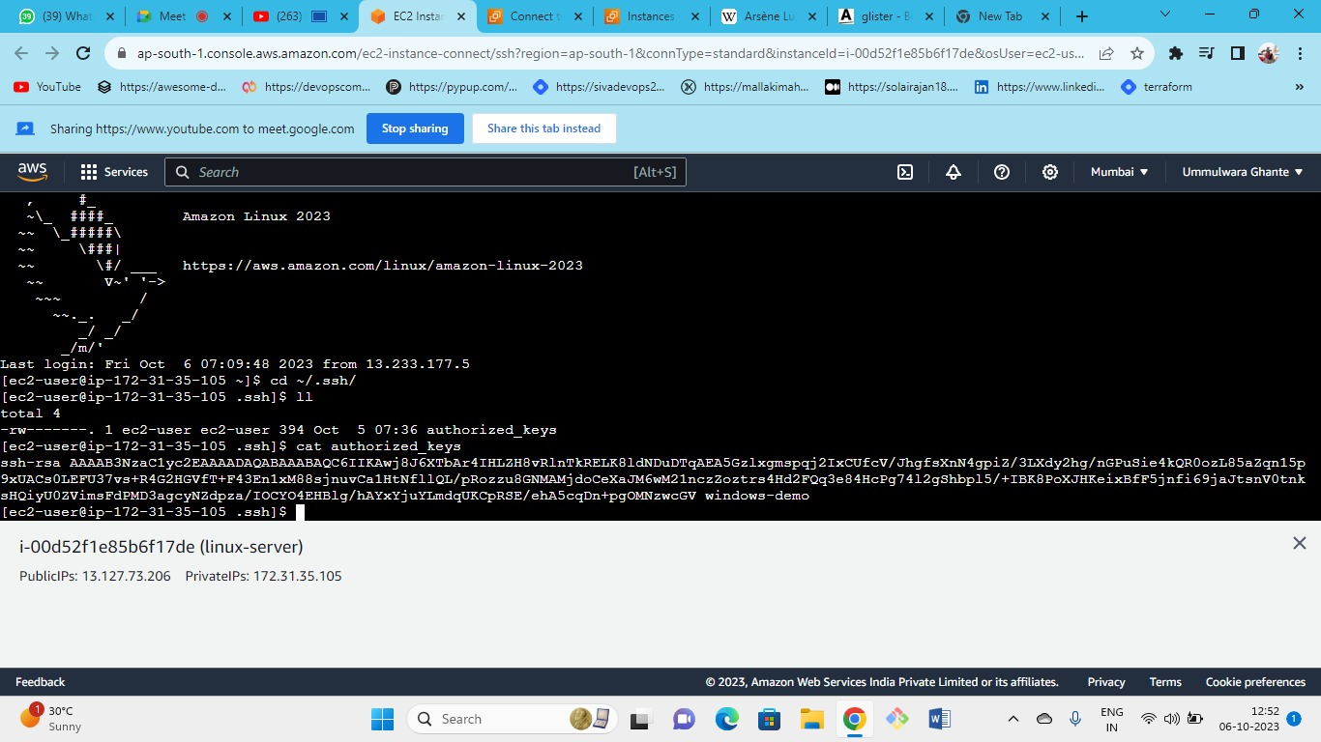



* When you connect SSH
* AWS do in the backend that the authorized key is public key that is available in the server where the server lies in the AWS data centre so AWS holds the public key.
* when you do the instance connect it temporarily pushes a public key to the server.
* While you do ec2 instance connect AWS will manage the public and private key mechanism.
* As we were accessing from our local machine we were only allowing MYIP but if we need to allow AWS IP’s to connect to the server we need to establish (ec2 instance connection with AWS), so we need to give access to AWS backend servers IP’s so that they can access to port 22 by giving permission. As we do not know the IPs of AWS that are being managed in backend so we need to open to anywhere.
* Instead of using anywhere in the source AWS provided the list of IP ranges that are used by servers in the backend as anywhere is not a good practice
* <https://docs.aws.amazon.com/vpc/latest/userguide/aws-ip-ranges.html#aws-ip-download>
* IP’s such as route53, workspace,cloud9, gateway, ec2 instance connect, s3, EBS etc

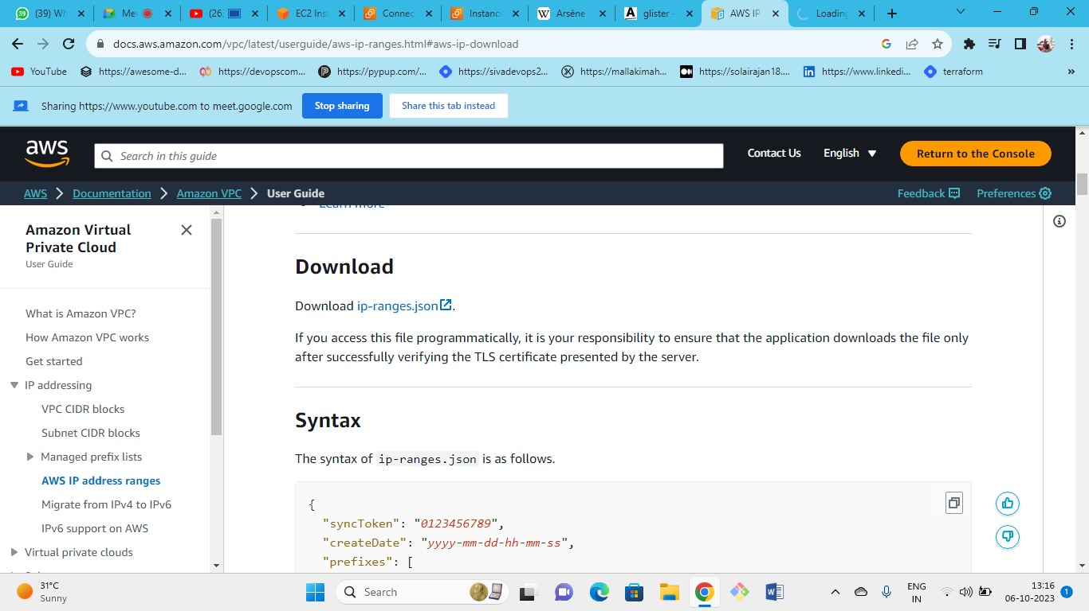

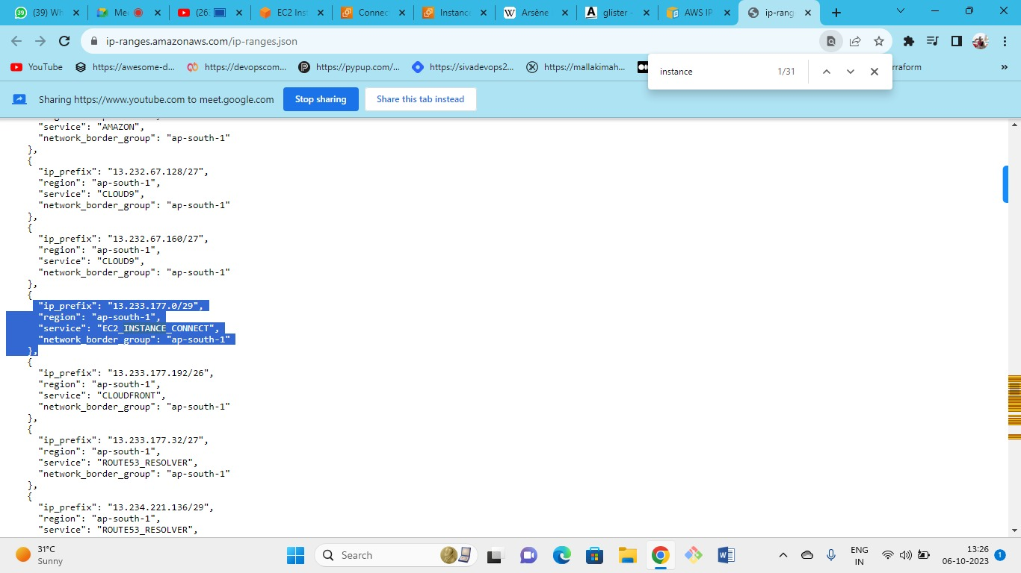

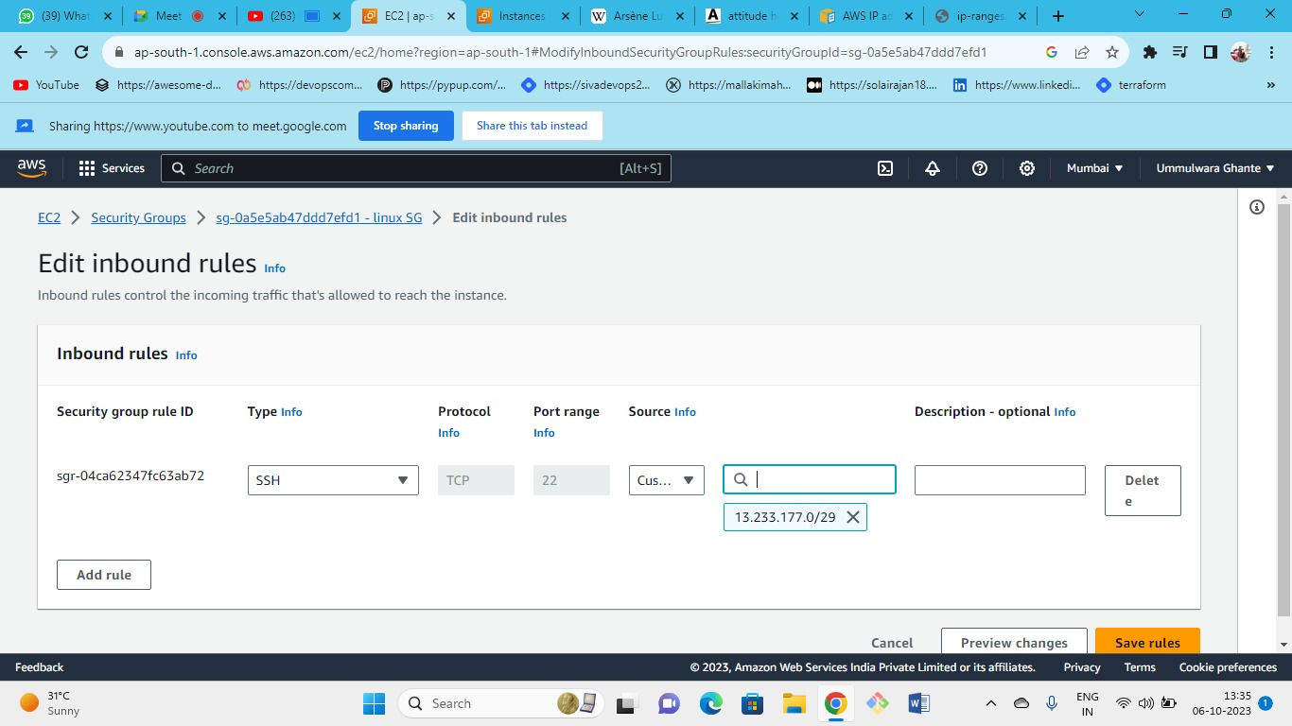



just paste the aws IP and try to connect it.

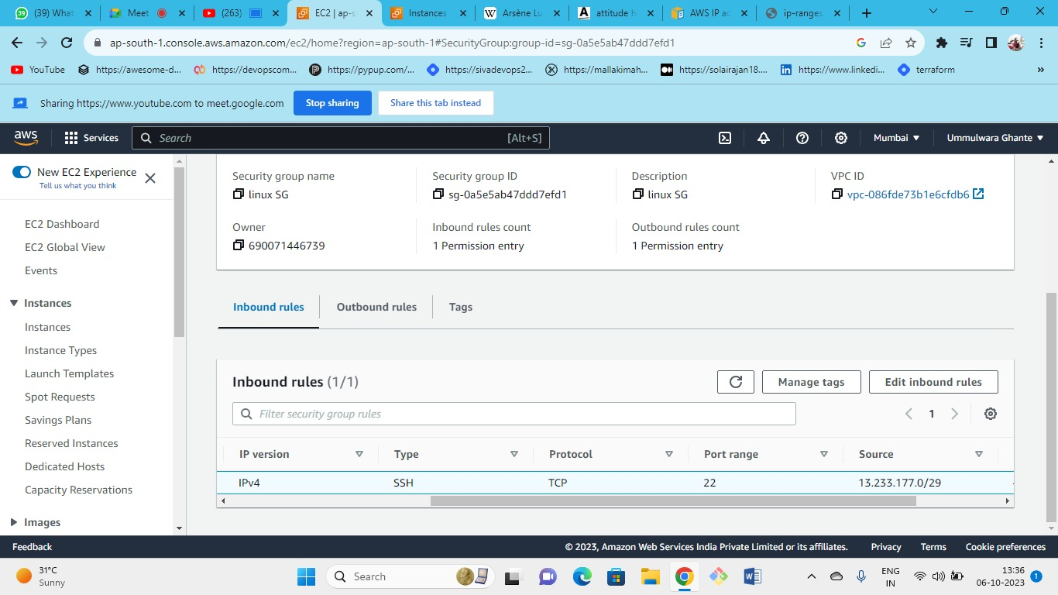

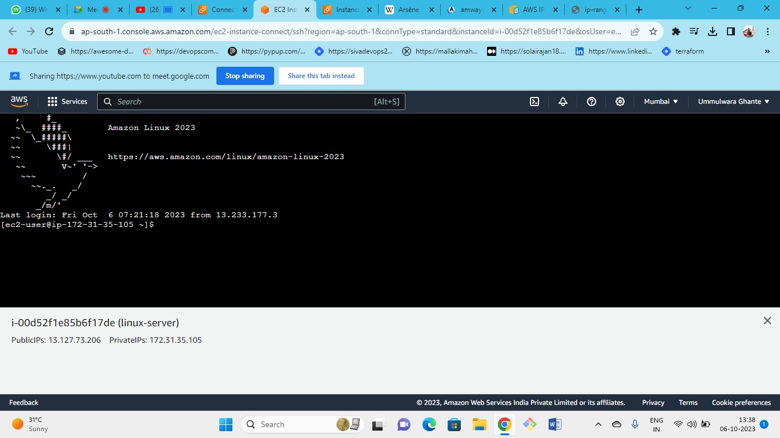

successfully connect by AWS IP’S

**By using CMD🡪 command prompt**

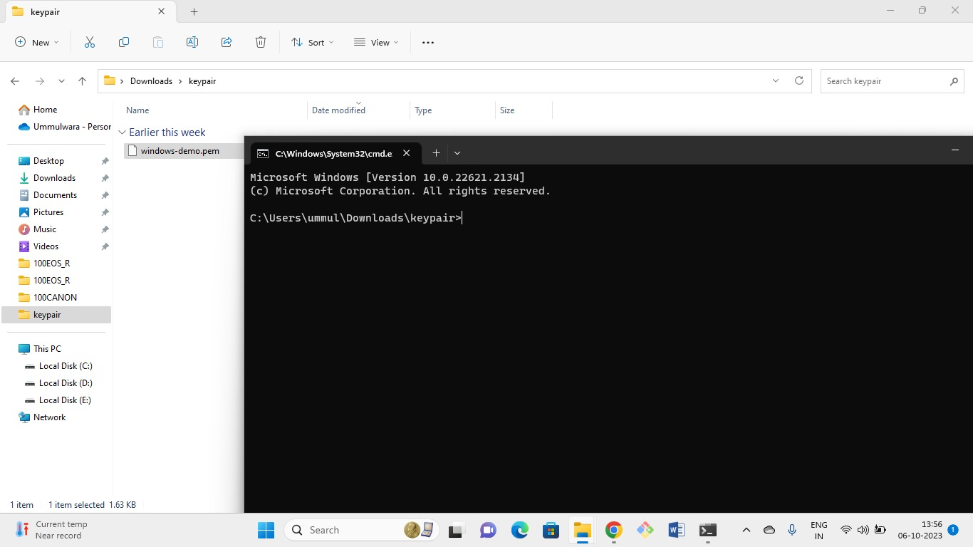

just in the path section write cmd

path section of key pair.

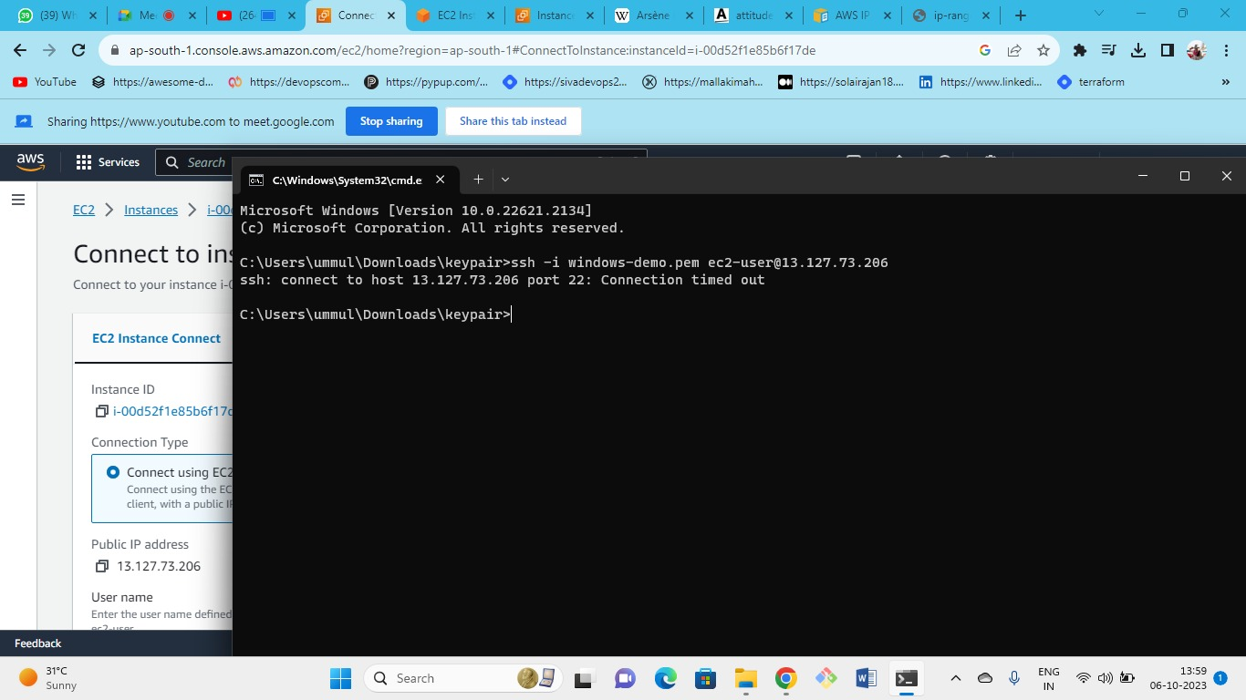

as there is a connection timeout you need to check the security group for port 22 and it should be open for my IP

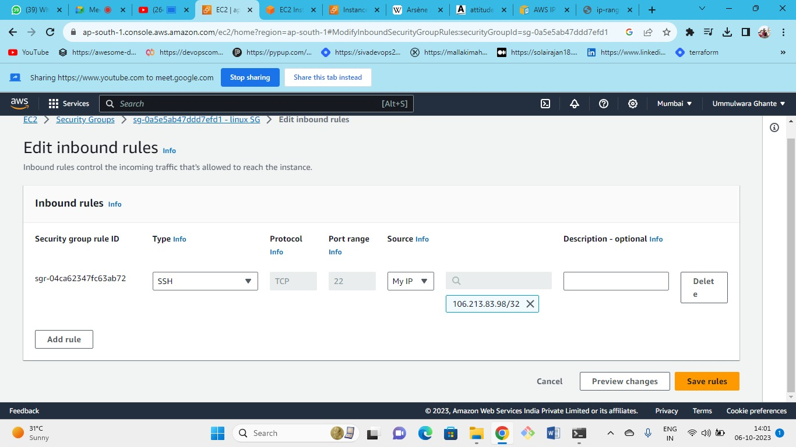



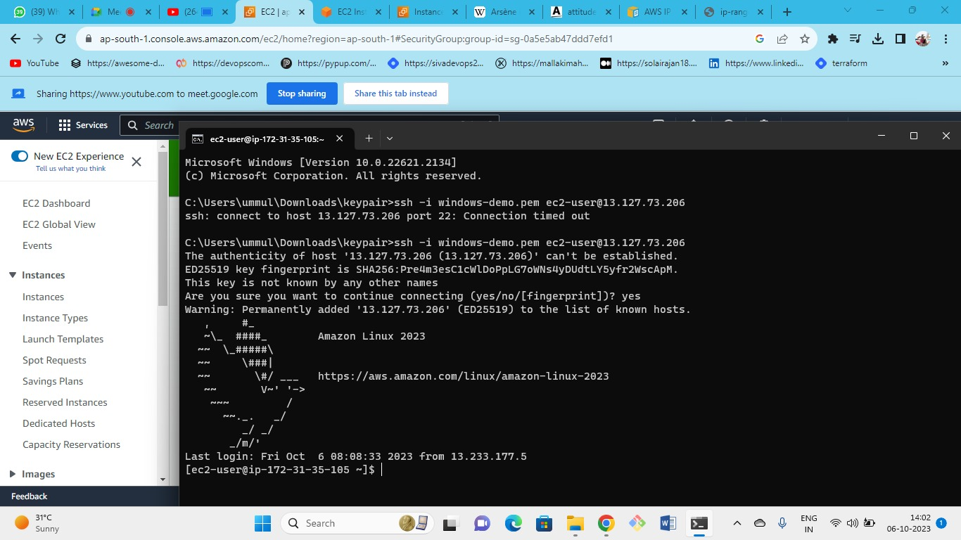

Connected

as we have first connected for aws IP now it is connected to my IP.

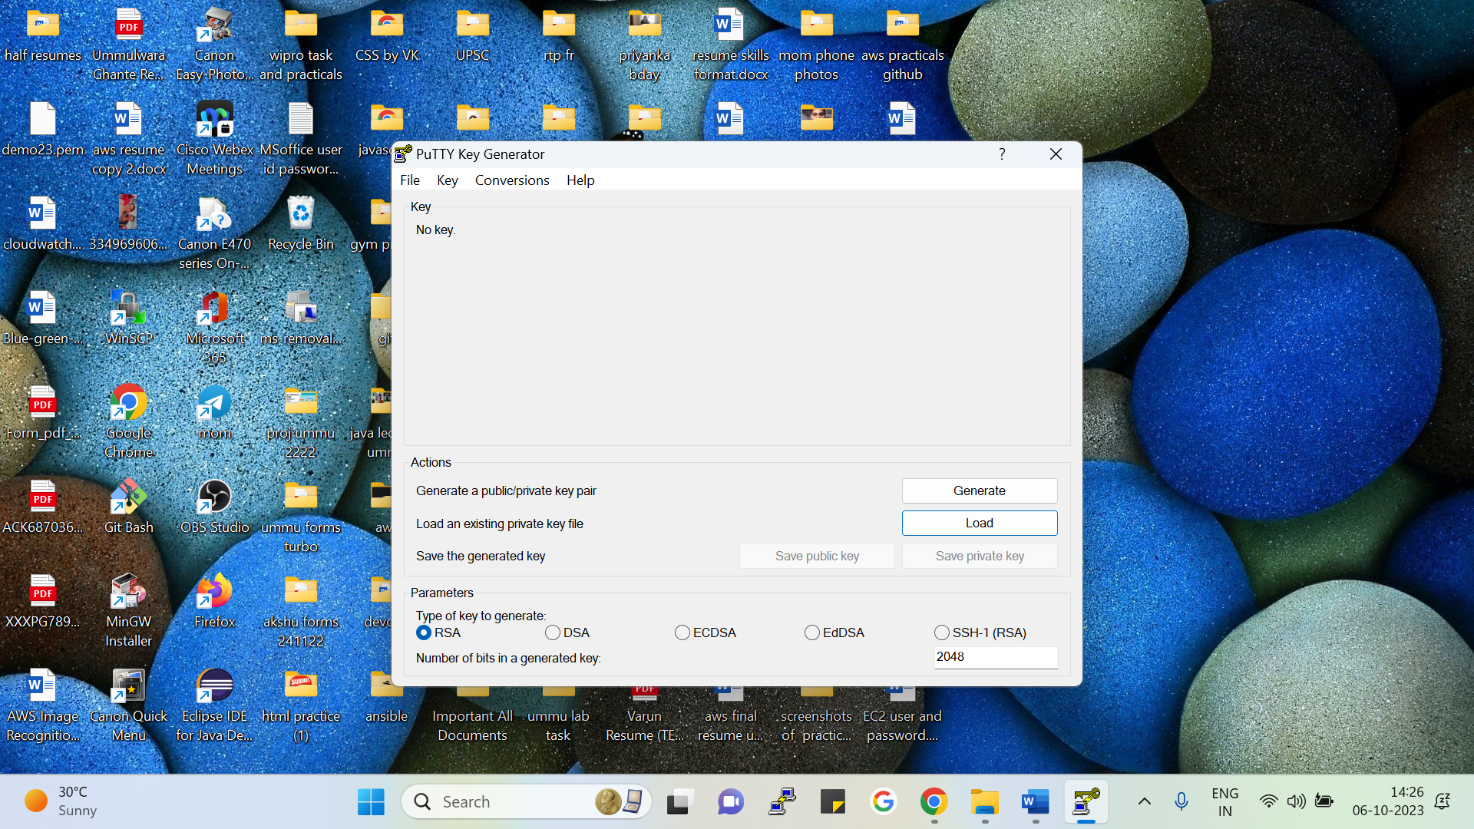

Just click on the load and then you need to paste .pem file and you will get .ppk file

